**Networking communication:**

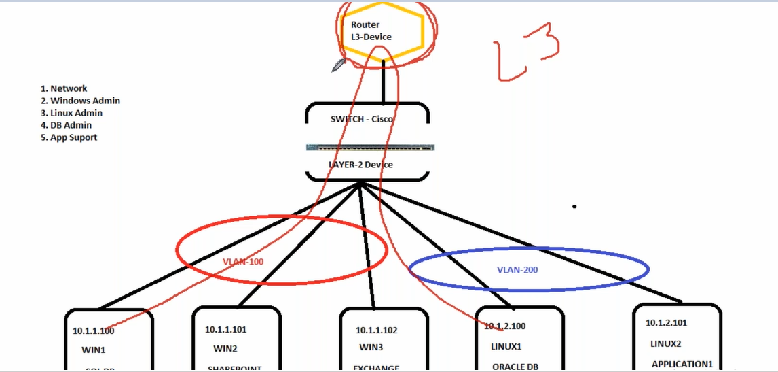

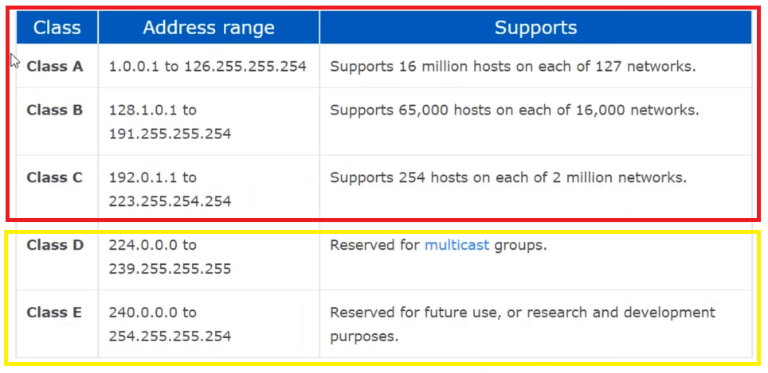

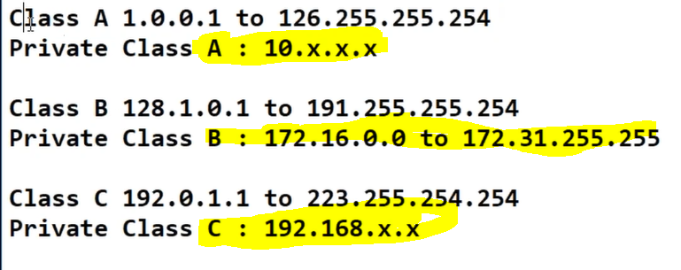

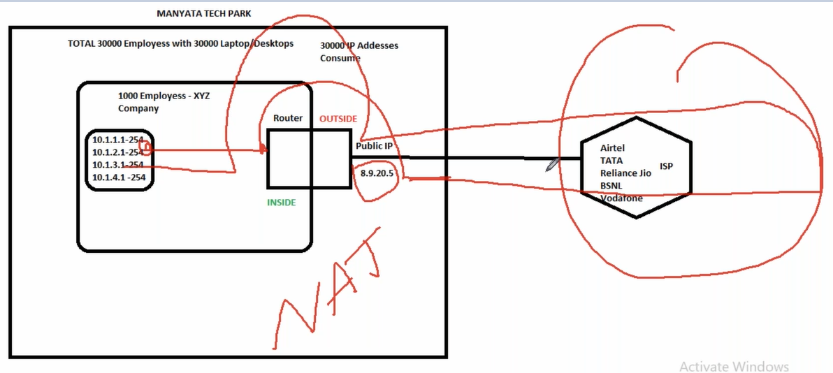

**Virtual private cloud:**

 The AWS Global Infrastructure is designed and built to deliver the most flexible, reliable, scalable, and secure cloud computing environment with the highest quality global network performance available today.

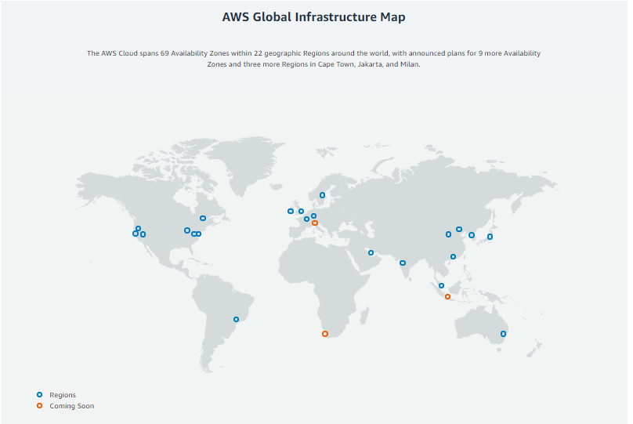

## Region

## Each AWS Region is a separate geographic area. Each AWS Region has multiple, isolated locations known as Availability Zones. (Where the AWS services are available)

## 

## 

## Availability Zones

**An Availability Zone is an isolated location inside a region**. Each region is made up of several Availability Zones. Each Availability Zones belong to a single region.   
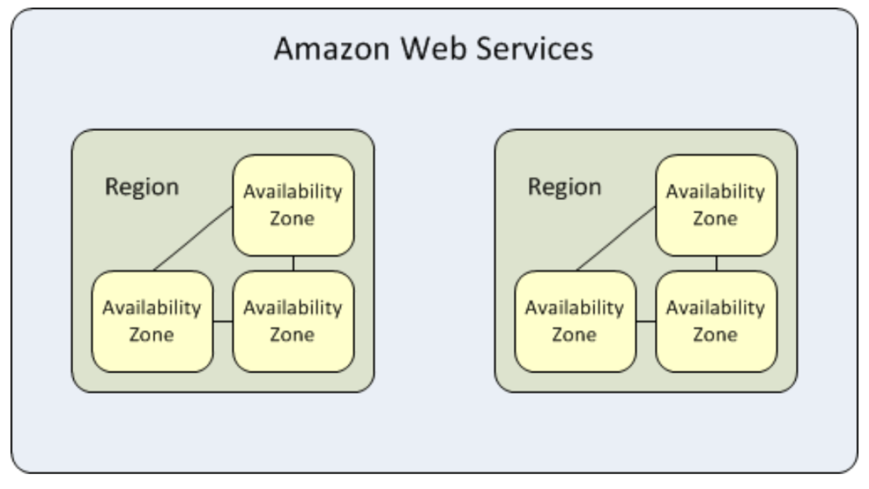

## Benefits:

### Performance

Performance is a important thing in design of the AWS Global Infrastructure. Whether it is compute, storage, database or networking, **companies need a high-performing, low latency cloud infrastructure**.

### Availability

Availability Zones are designed for physical redundancy, enabling uninterrupted performance, even in the event of power outages, Internet downtime, floods, and other natural disasters.

### Security

### Customers can build on the most secure global infrastructure, knowing they always own their data, including the ability to encrypt it, move it, and manage retention.

### Scalability

The AWS Global Infrastructure enables companies to be extremely flexible and take advantage of the conceptually infinite scalability of the cloud.

### Reliability

The AWS Global Infrastructure is designed and built for redundancy and reliability, from regions to networking links to load balancers to routers to firmware. For example, in order to offer maximum resiliency against system disruptions, AWS builds its data centers in multiple geographic Regions as well as across multiple AZs within each Region. Each Region is isolated from the others. And AWS AZs are true AZs: completely separate buildings kilometers apart for complete redundancy.

**Public cloud**— A public cloud is a cloud service offered to multiple customers by a cloud providers

**Private cloud** ---(Openstack) A private cloud is a cloud that only one organization can access

**Hybrid** ---Private + Public

**Virtual private cloud ::**

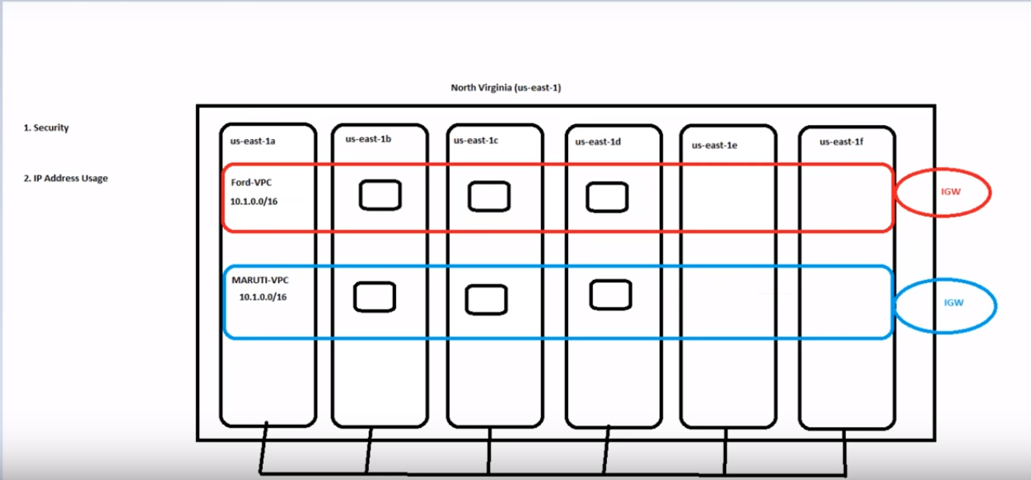

Amazon Virtual Private Cloud (Amazon VPC) enables you to launch AWS resources into a virtual network that you've defined.

==Datacenters

This virtual network closely resembles a traditional network that you'd operate in your own data center, with the benefits of using the scalable infrastructure of AWS.

* VPC is regional dependent
* VPC is not AZ dependent

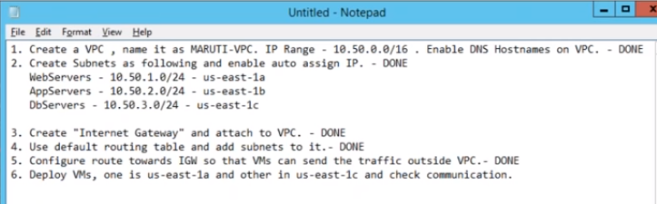

**Create a VPC (VPC is region specific)**

**Q::Can’t we modify default VPC ,to customize with our requirements==yes we can but we can’t create default VPC again.**

**Q:: Can we change IP pools in VPC’s :: Ans :: YES**

**What is inter-region VPC peering connection?**

Inter-Region VPC Peering allows VPC resources running in different AWS Regions to communicate with each other using private IP addresses, without requiring gateways, VPN (Virtual Private Network) connections or separate physical hardware.

**Can we migrate servers from one VPC to other?--no**

**Note :: If you give same IPv4 between different availability zone ,it’ll provide error as below.**

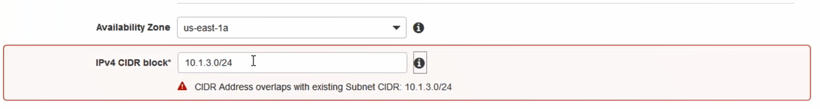

**Note :: We can put 1 or more subnets on same availability zone,provided if IPv4 is diff.**

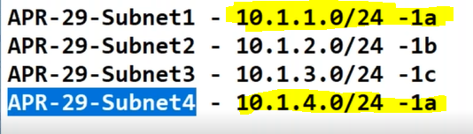

A VPC is an isolated portion of the AWS cloud .You must specify an IPv4 address range for your VPC. Specify the IPv4 address range as a Classless Inter-Domain Routing (CIDR) block; for example, **10.0.0.0/16**. **You cannot specify an IPv4 CIDR block larger than /28.** You can optionally associate an Amazon-provided IPv6 CIDR block with the VPC.

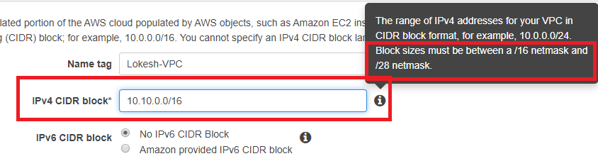

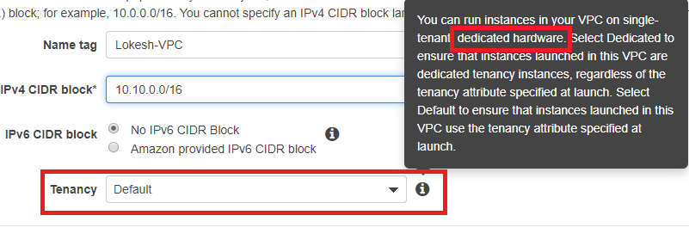

**Can we add multiple CIDR’s for VPC** ? –yes but those should be in the same range//

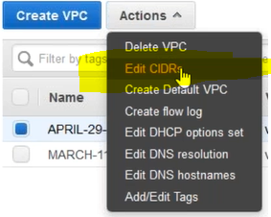

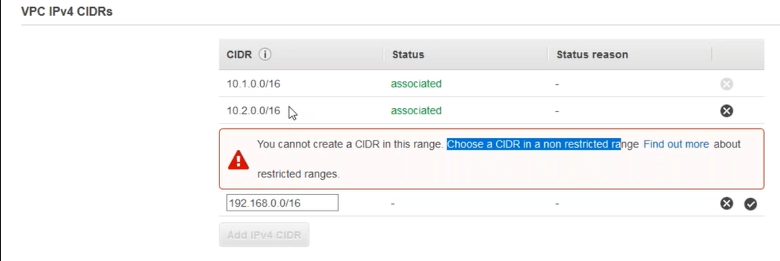

**2.Create subnets:**

A subnet is a range of IP addresses in your VPC. You can launch AWS resources into a specified subnet. Use a public subnet for resources that must be connected to the internet, and a private subnet for resources that won't be connected to the internet.

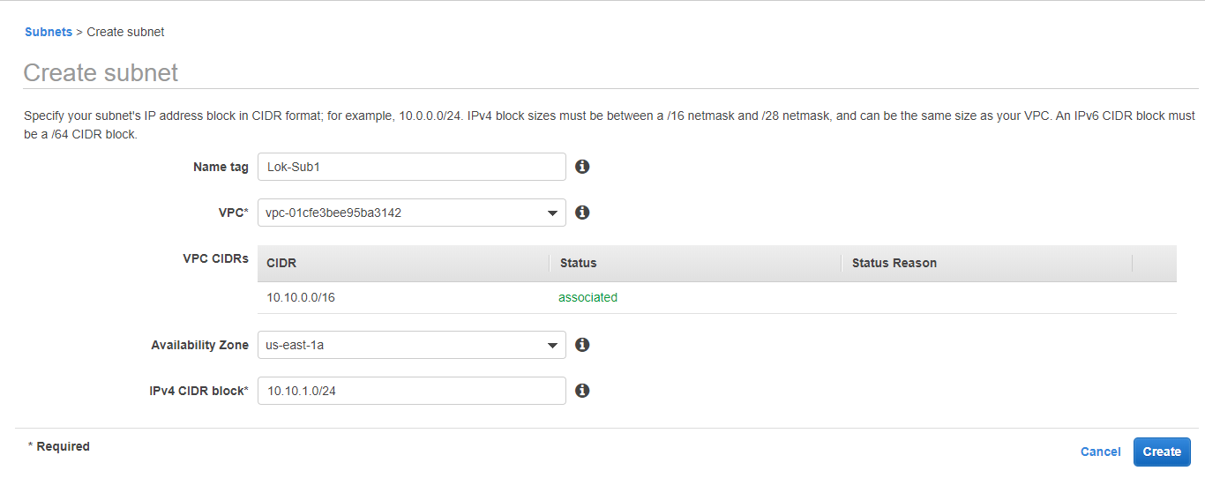

3 subnets:

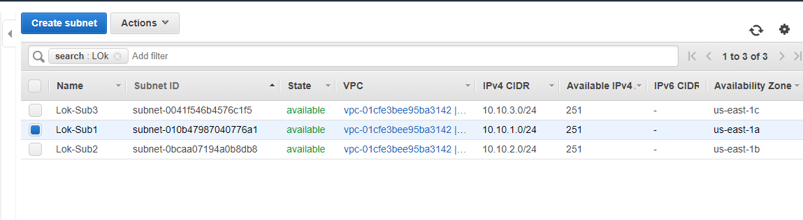

3. **Internet Gateway**:IGW(One IGW for every VPC) ,after creating an IGW attach it to VPC

It’s a virtual router that connects a VPC to the internet.

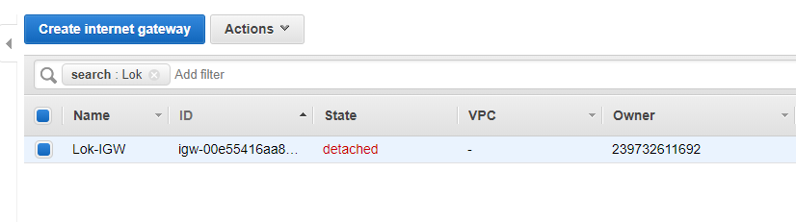

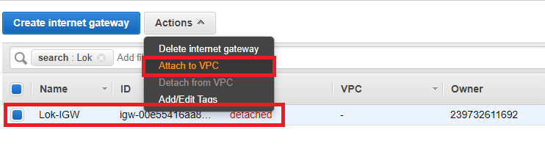

**4.Route table**: (One route table will be created when you create a VPC).

Basically it tells how packets are forwarding b/w the subnets within the VPC, in VPN connection.

1.Add subnets association

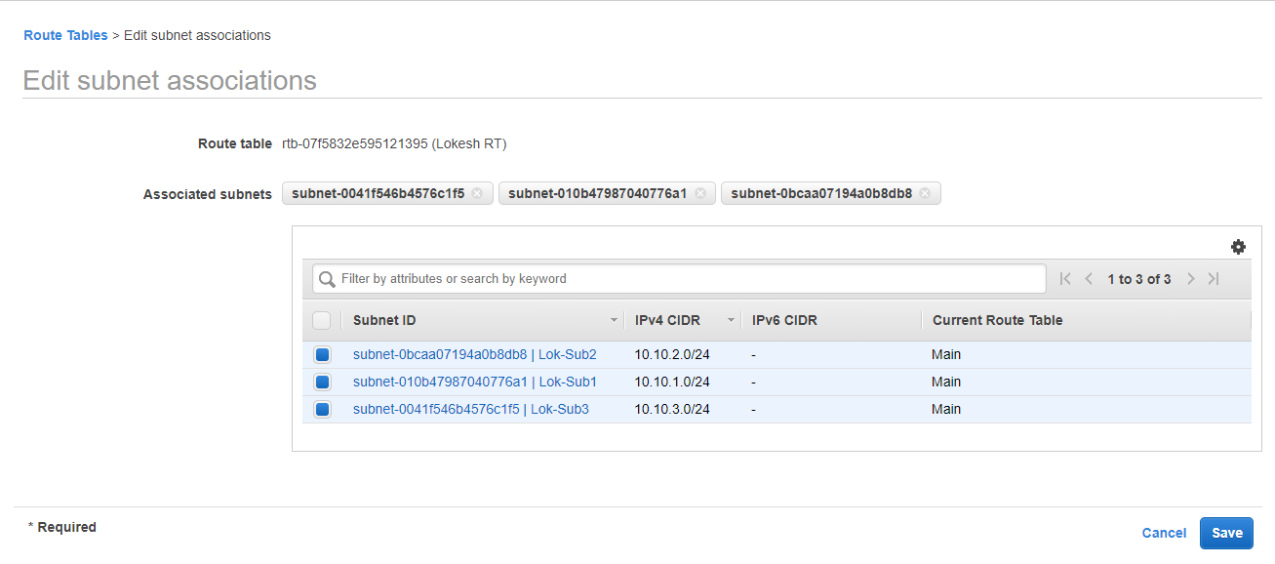

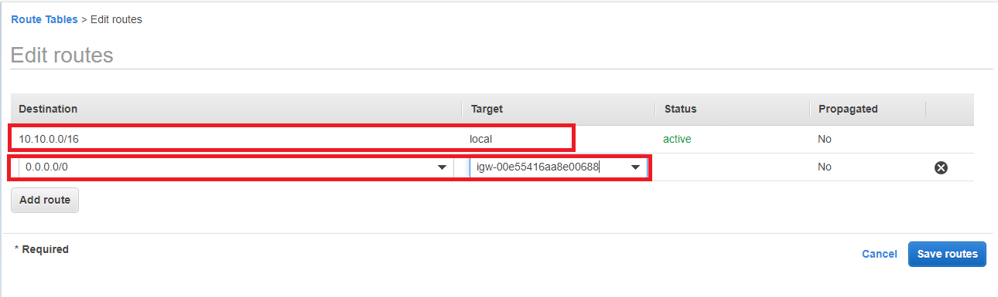

Within 10.10.0.0—network communication will be local,(Comm will happen default)

Anything other than 10.10.0.0 network should use IGW.

**5.Launch an Ec2 instances on each subnets:**

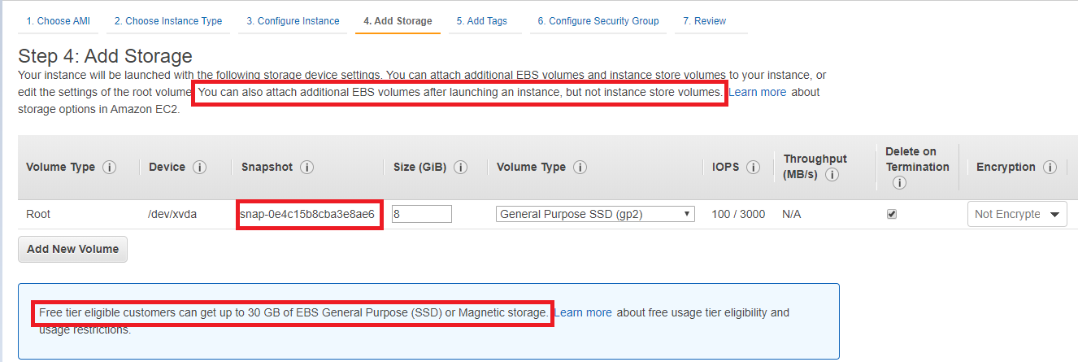

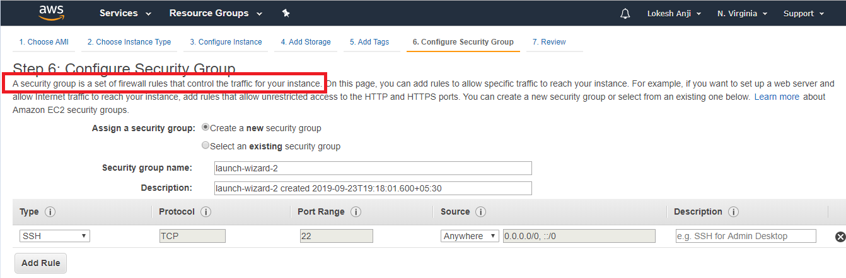

• **Security groups** — Act as a firewall for associated Amazon EC2 instances, controlling both inbound and outbound traffic at the instance level.

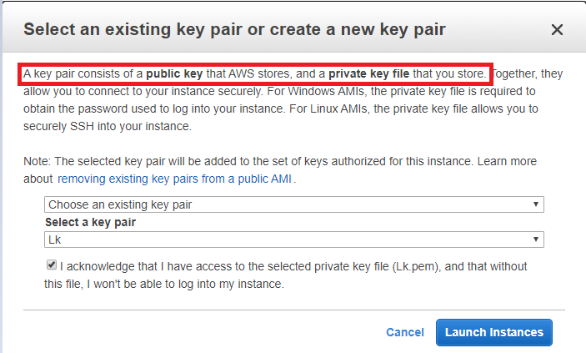

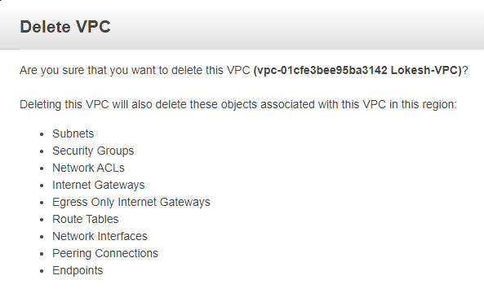

**Accessing the Internet:**

Your default VPC includes an internet gateway, and each default **subnet is a public subnet**. Each instance that you launch into a default subnet has a private IPv4 address and a public IPv4 address. These instances can communicate with the internet through the internet gateway. An internet gateway enables your instances to connect to the internet through the Amazon EC2 network edge.

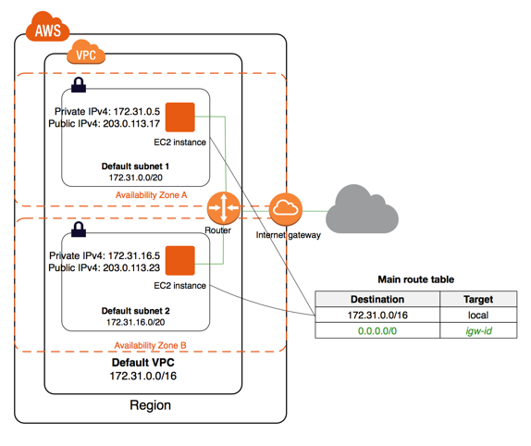

By default, each instance that you launch into a non-default subnet has a private IPv4 address, but no public IPv4 address, unless you specifically assign one at launch, or you modify the subnet's public IP address attribute. These instances can communicate with each other, but can't access the internet.

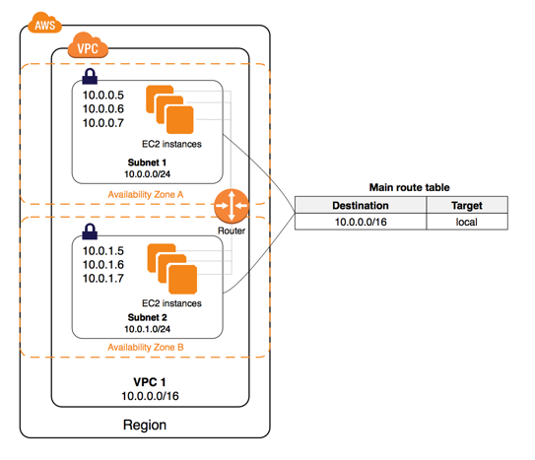

You can enable internet access for an instance launched into a non-default subnet by attaching an internet gateway to its VPC (if its VPC is not a default VPC) and associating an Elastic IP address with the instance.

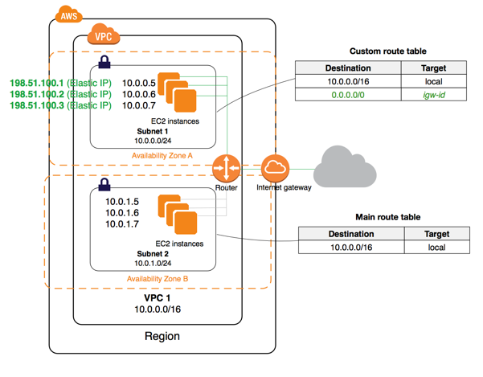

Alternatively, to allow an instance in your VPC to initiate outbound connections to the internet but prevent unsolicited inbound connections from the internet, you can use a network address translation (NAT) device for IPv4 traffic.

You can use a NAT device to enable instances in a private subnet to connect to the internet (for example,for software updates) or other AWS services, but prevent the internet from initiating connections with the instances. A NAT device forwards traffic from the instances in the private subnet to the internet or other AWS services, and then sends the response back to the instances. When traffic goes to the internet, the source IPv4 address is replaced with the NAT device’s address and similarly, when the response traffic goes to those instances, the NAT device translates the address back to those instances’ private IPv4 addresses.

**NAT Gateways:**

You can use a network address translation (NAT) gateway to enable instances in a private subnet to connect to the internet or other AWS services, but prevent the internet from initiating a connection with those instances. For more information about NAT.**You are charged for creating and using a NAT gateway in your account. NAT gateway hourly usage and data processing rates apply.** Amazon EC2 charges for data transfer also apply.

The following diagram illustrates the architecture of a VPC with a NAT gateway. The main route table sends internet traffic from the instances in the private subnet to the NAT gateway. The NAT gateway sends the traffic to the internet gateway using the NAT gateway’s Elastic IP address as the source IP address.

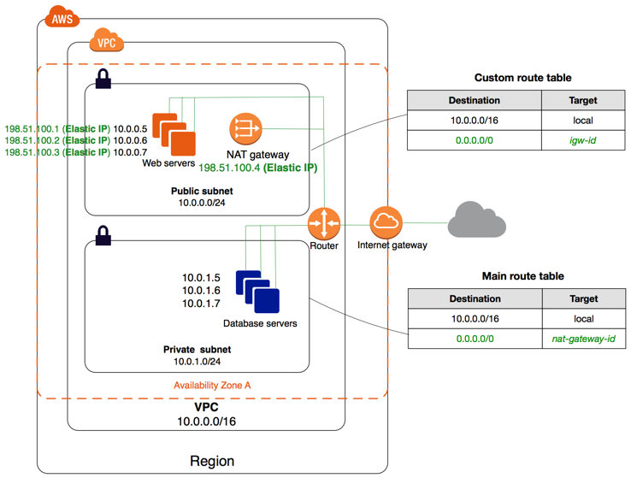

**NAT Gateway Rules and Limitations**

A NAT gateway has the following characteristics and limitations:

* A NAT gateway supports 5 Gbps of bandwidth and automatically scales up to 45 Gbps. If you require more, you can distribute the workload by splitting your resources into multiple subnets, and creating a NAT gateway in each subnet.
* You can associate exactly one Elastic IP address with a NAT gateway. You cannot disassociate an Elastic IP address from a NAT gateway after it's created. To use a different Elastic IP address for your NAT gateway, you must create a new NAT gateway with the required address, update your route tables, and then delete the existing NAT gateway if it's no longer required.
* A NAT gateway supports the following protocols: TCP, UDP, and ICMP.

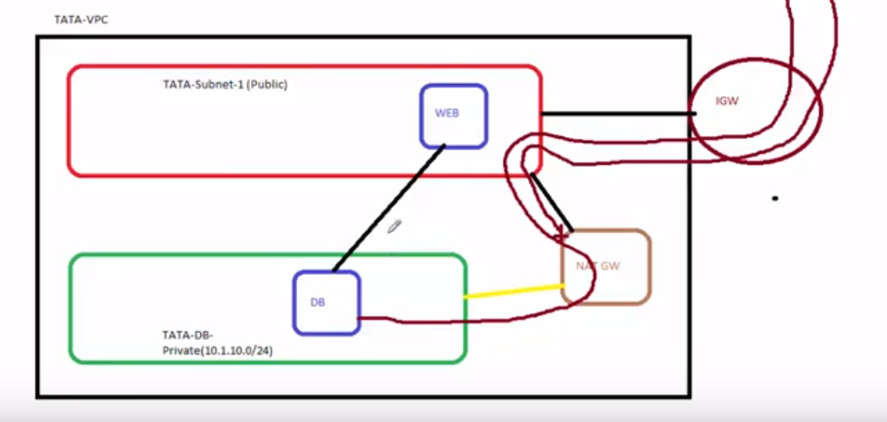

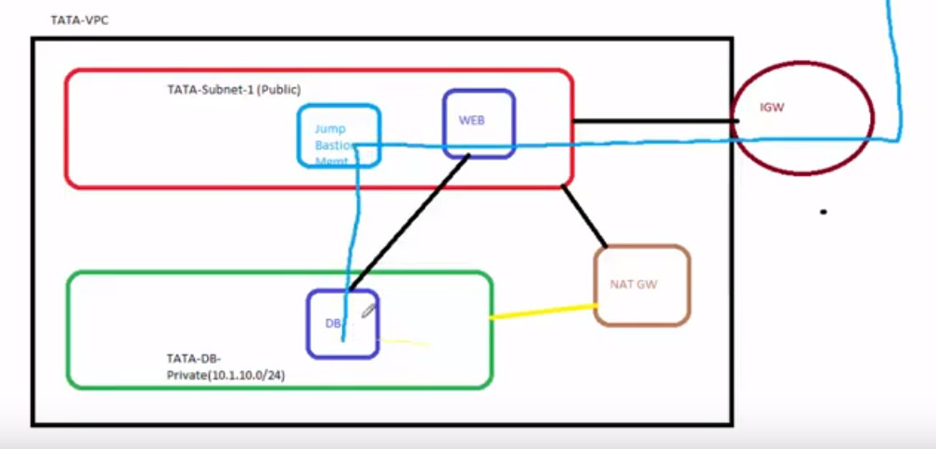

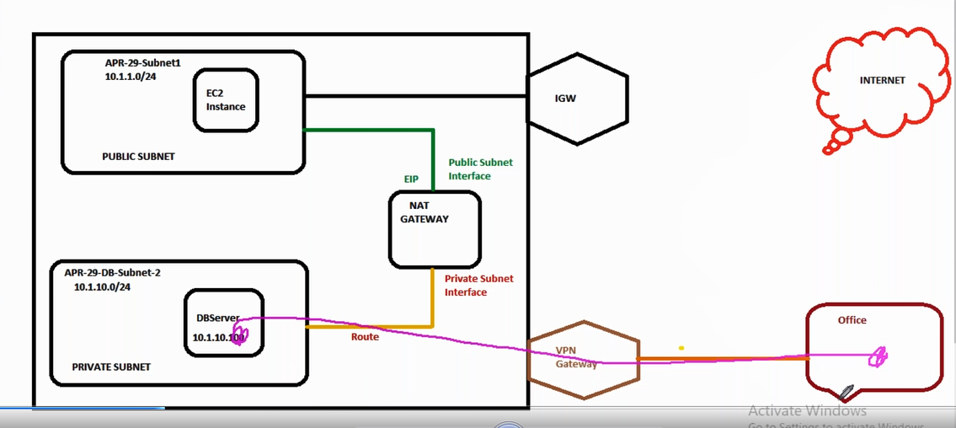

**Steps :**

**1**.Create a new subnet and name it as **private** subnet 10.10.2.0/24

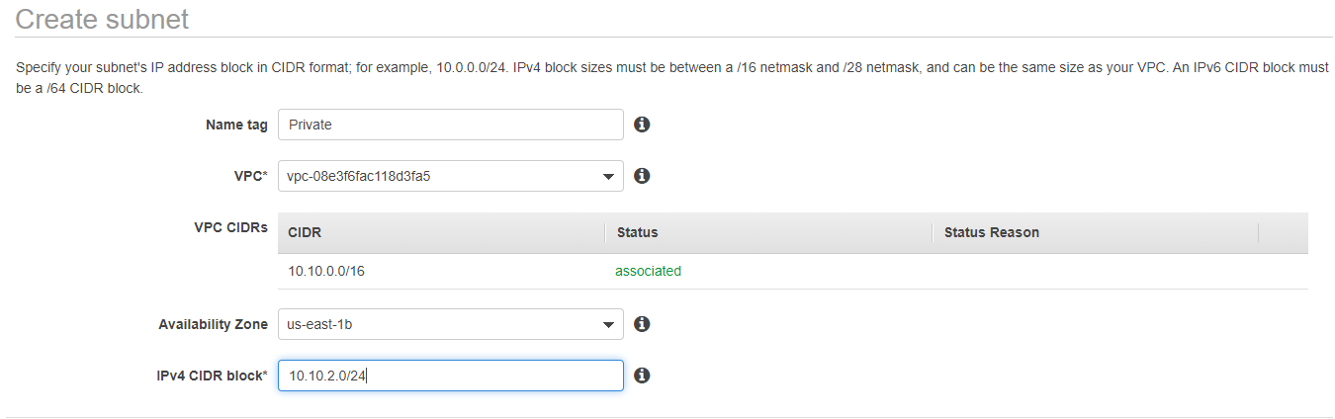

**2.**Create a new RT name it as Private-RT and add private subnet to it.(Don’t attach internet gateway to this)

**3**.Launch one instance in public,private instances .We can’t be able to access the ins on the private subnet as it not exposed to internet via IGW.

**4**. Allocate a new EIP and associate that to the public instance.

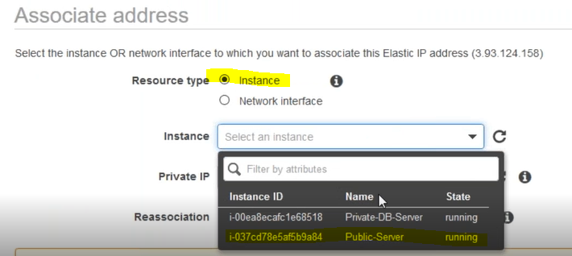

**5.**Create a NAT gateway and **attach it to public subnet**,and **add the NAT gateway entry on the private subnet** route table.

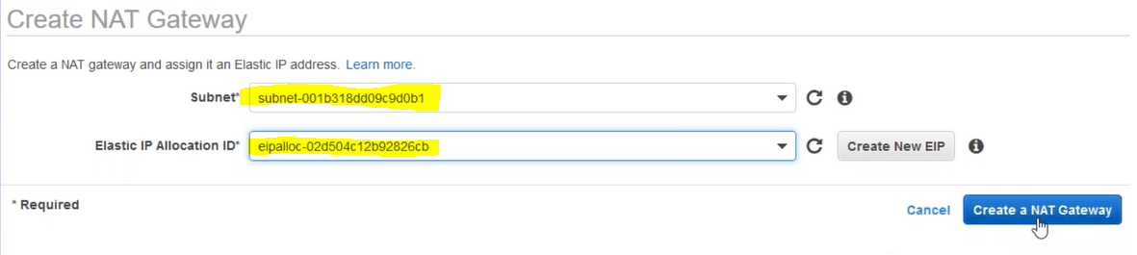

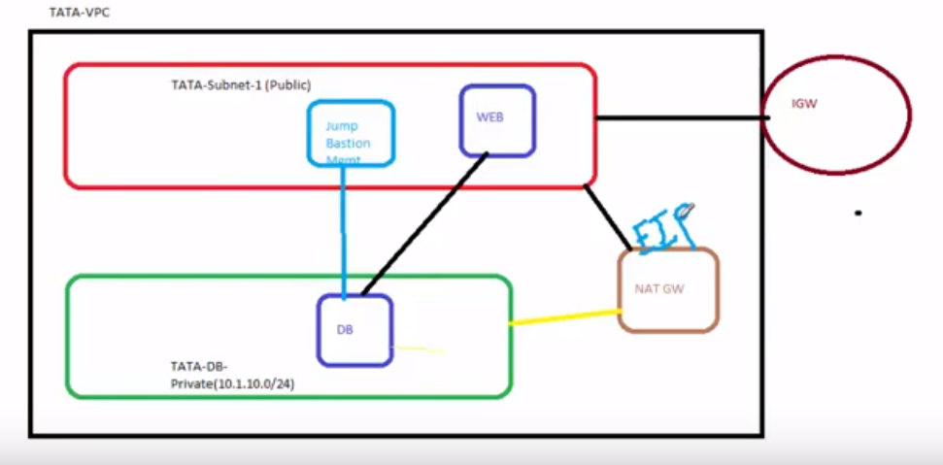

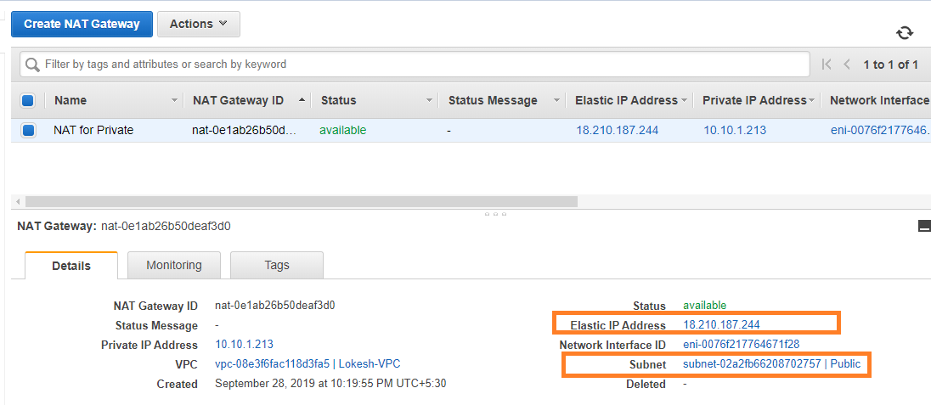

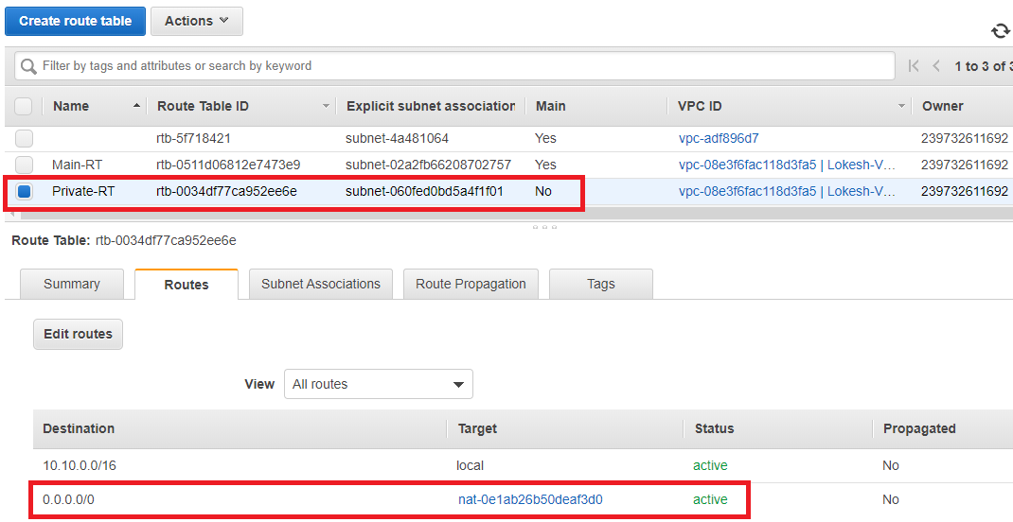

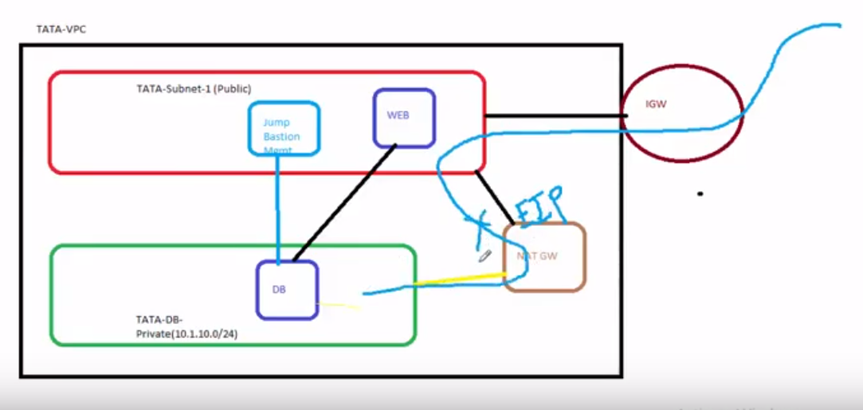

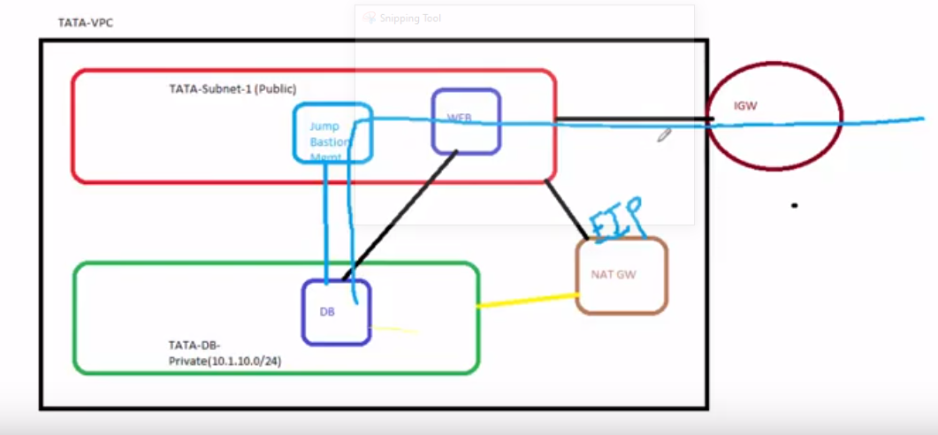

Note;::”The jump or web server on the public subnet can ping DB server on the private subnet ,as the ports are opended from either end and also we know the Ipv4 address of DB server but in the real time environment it is not the use case.

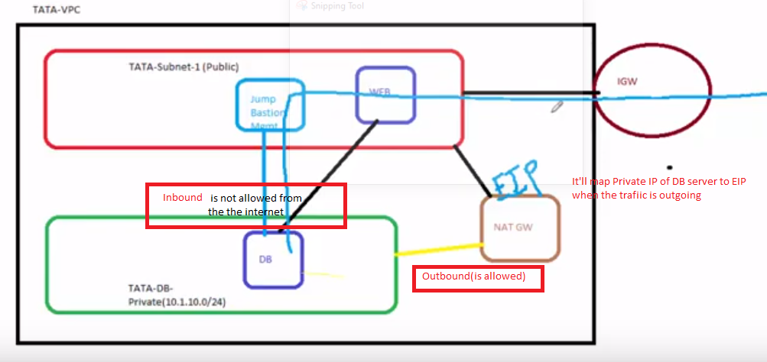

Note :: EIP will be chargable if you don’t assign,Also for NAT gateway per hour charge(0.045$) and the amount of data it is moving.

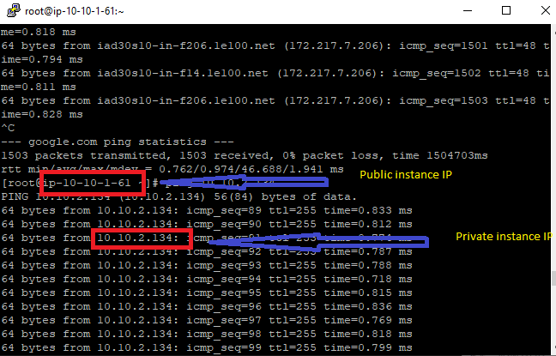

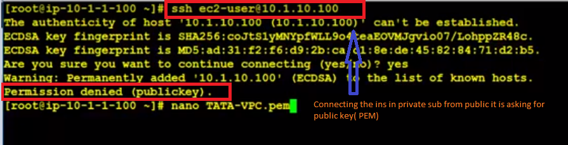

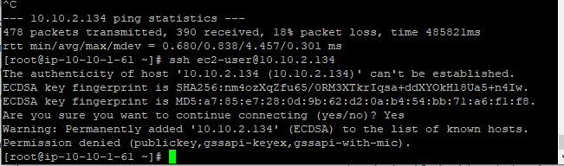

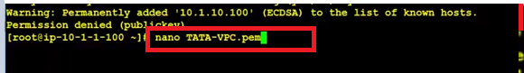

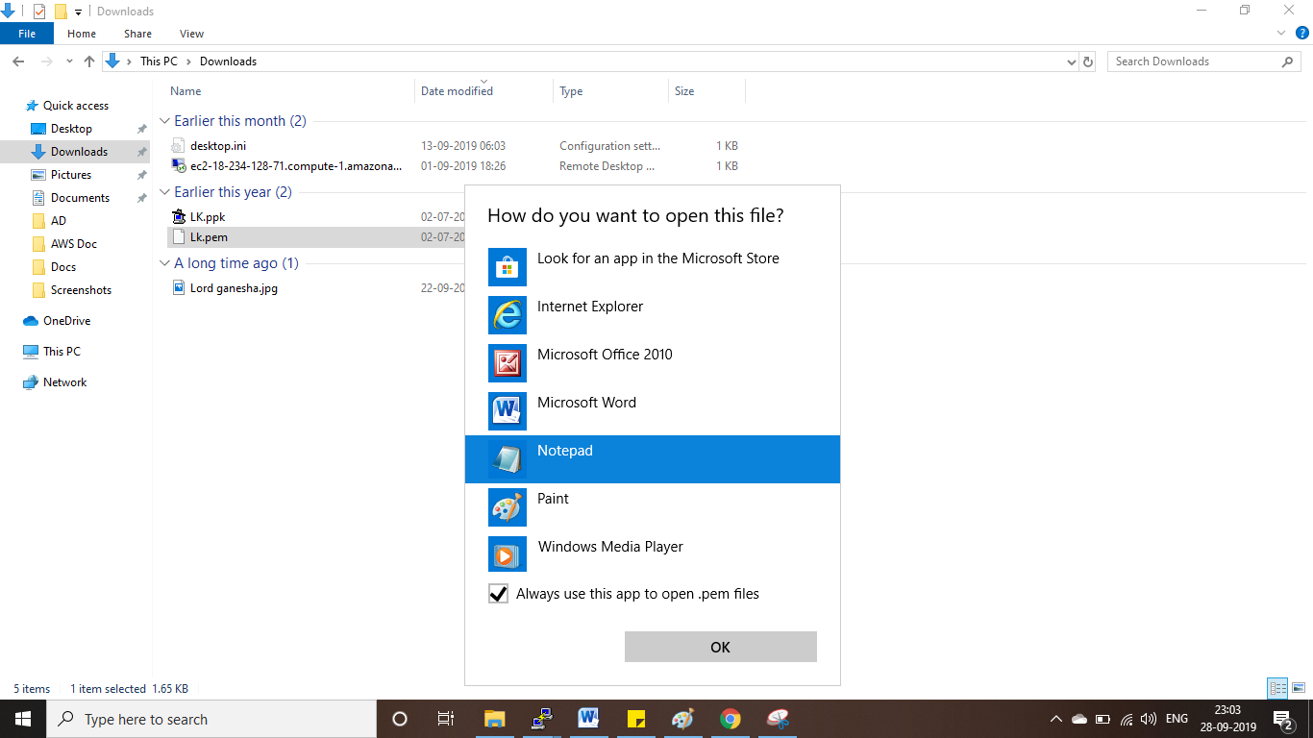

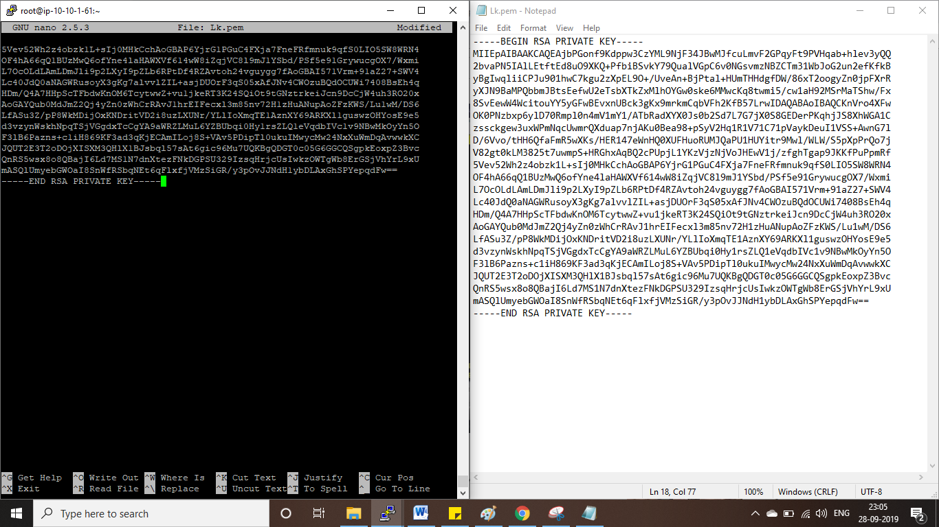

Ctrl+O and Enter for saving  
Ctrl+X for exit

Cat Lk.pem for seeing

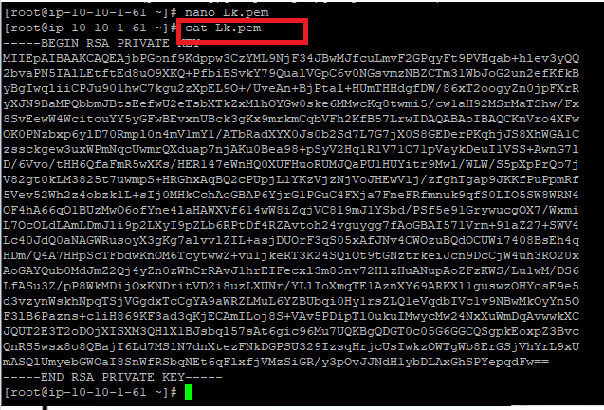

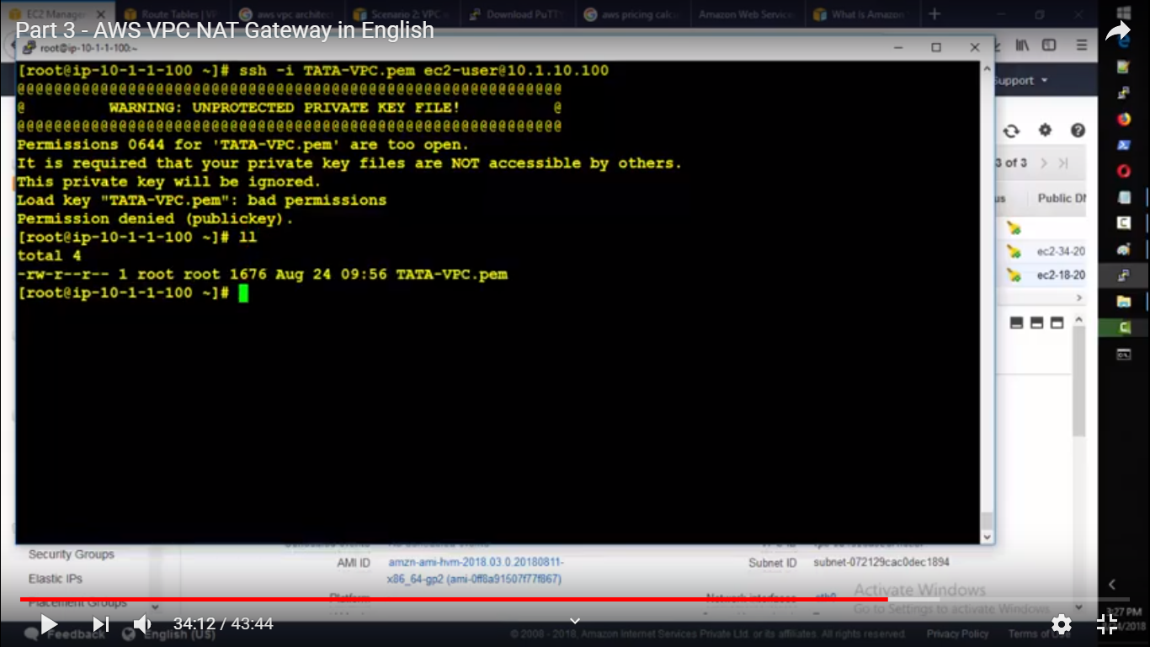

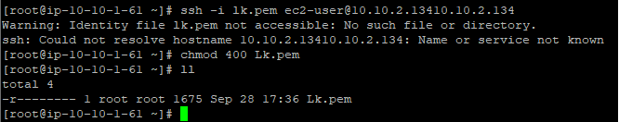

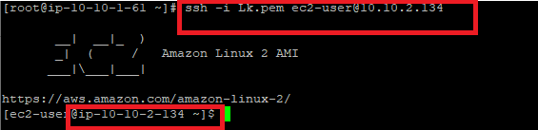

**Accessing a Corporate or Home Network**

You can optionally connect your VPC to your own corporate data center using an IPsec AWS Site-to-Site VPN connection, making the AWS Cloud an extension of your data center.

A Site-to-Site VPN connection consists of a virtual private gateway attached to your VPC and a customer gateway located in your data center. A virtual private gateway is the VPN concentrator on the Amazon side of the Site-to-Site VPN connection. A customer gateway is a physical device or software appliance on your side of the Site-to-Site VPN connection.

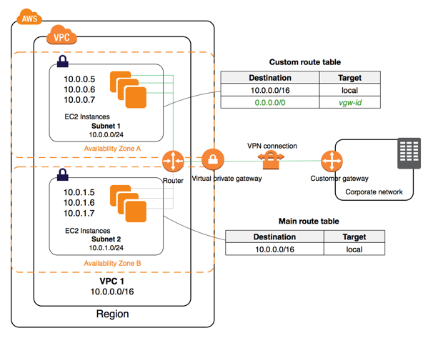

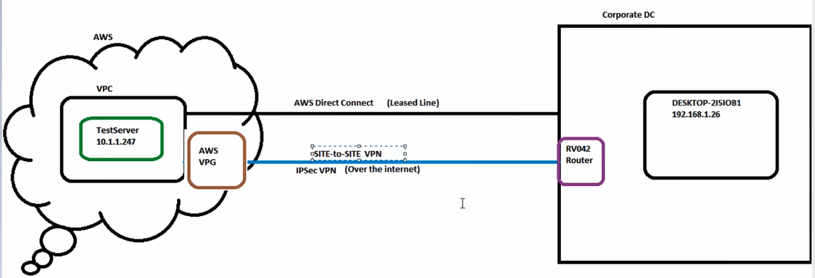

**1.Create Customer gateway:**

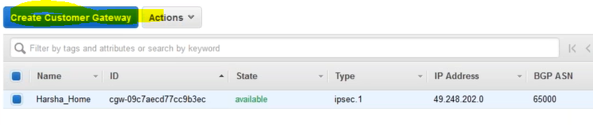

2. **Create Virtual private gateway:**

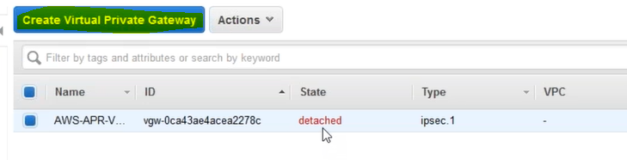

**3. Attach it to VPC:**

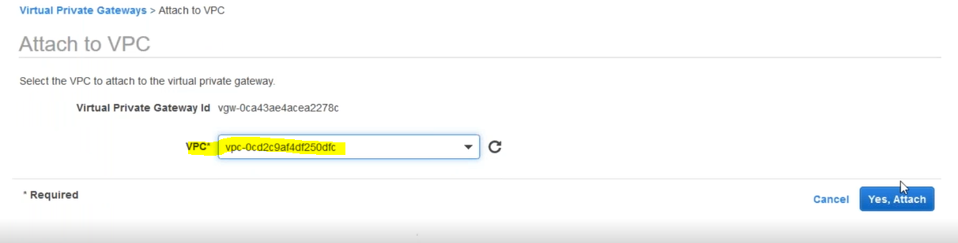

**4.Create VPN connection**

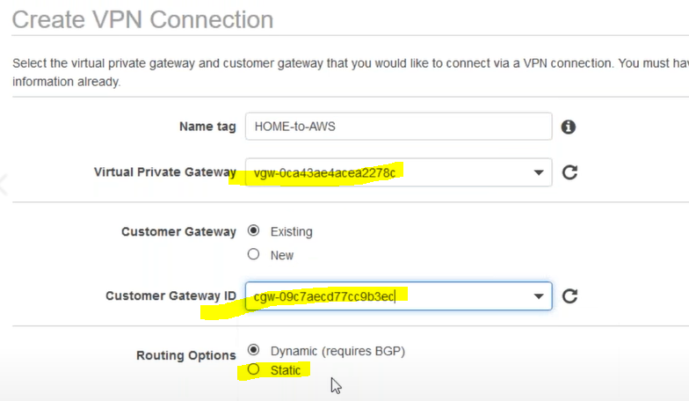

**5.Download configuration**

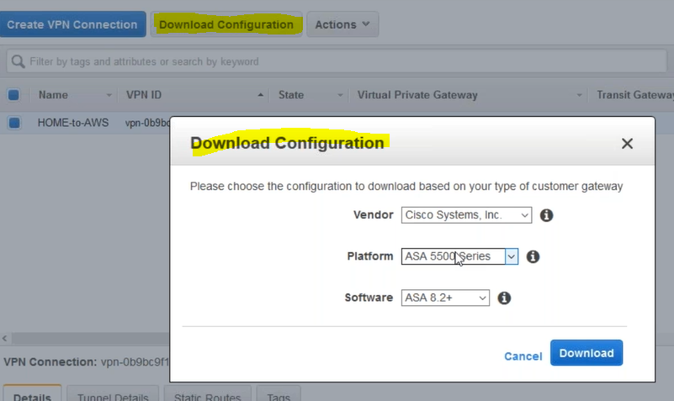

**What is route propogation ?**

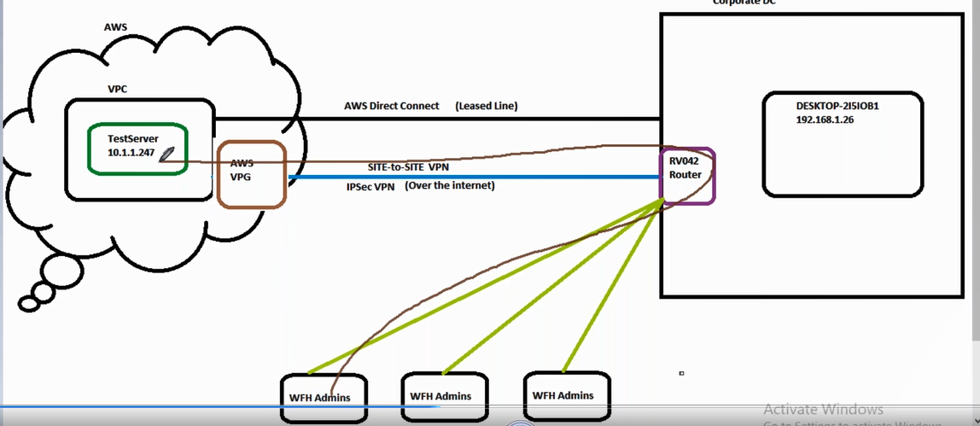

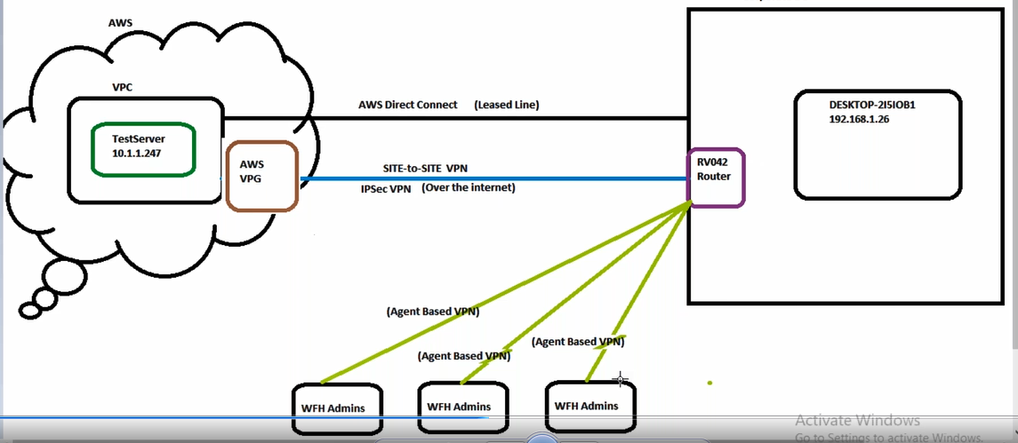

**Point to site VPN:**

**Site to Site VPN ::1.Direct connect 2.IPSec**

Q :: Whether we can only access the instance which are in the same VPC ,on which OpenVPN server is attached.

**VPC peering :**

Establishing communication b/w two diff n/w using private IP’s which may be in same(Intra) or diff region(Inter).



<https://docs.aws.amazon.com/vpc/latest/peering/what-is-vpc-peering.html>

A VPC peering connection is a networking connection between two VPCs that enables you to route traffic between them using private IPv4 addresses or IPv6 addresses. Instances in either VPC can communicate with each other as if they are within the same network. You can create a VPC peering connection between your own VPCs, or with a VPC in another AWS account. The VPCs can be in different regions (also known as an inter-region VPC peering connection).

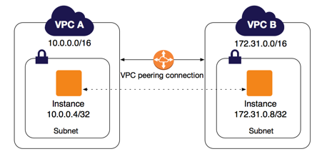

AWS uses the existing infrastructure of a VPC to create a VPC peering connection; it is neither a gateway nor a VPN connection, and does not rely on a separate piece of physical hardware. There is no single point of failure for communication or a bandwidth bottleneck.

A VPC peering connection helps you to facilitate the transfer of data. For example, if you have more than one AWS account, you can peer the VPCs across those accounts to create a file sharing network. You can also use a VPC peering connection to allow other VPCs to access resources you have in one of your VPCs.

You can establish peering relationships between VPCs across different AWS Regions (also called Inter-Region VPC Peering). This allows VPC resources including EC2 instances, Amazon RDS databases and Lambda functions that run in different AWS Regions to communicate with each other using private IP addresses, without requiring gateways, VPN connections, or separate network appliances.

---------------------------------------------------------------------------------------------------------------------------------------------------**Creating VPC peering** ::

Q:: Need to check whether we can assign same IP’s to the servers on different VPC.

1.Create 3 VPC’s in different regions

Lokesh-NV :: 10.10.0.0/16---vpc-0db83c3f2385fee4b

Lokesh-OH :: 172.10.0.0/16---vpc-03106c01cd4589cbd

Lokesh-MUM :: 192.168.0.0/16--vpc-0556b17237b2dfd12

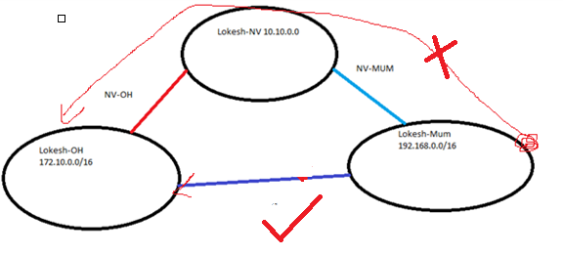

2.Launch 3 instances ,one in each regions,use the same key-pair(ec2-metadata),by importing.

3.Create a peering between the VPC’s

NV-MUM---pcx-02d0a1128bc8d7180

NV-OH-----pcx-0f7fd4aba469019a0

NV-Ins----- 10.10.1.156

OH-INS---- 172.10.1.202

MUM-INS---192.168.46.250

**Note**:: After creating peering ,if we’re not modifying RT ,the ping req will dropped at the IGW.

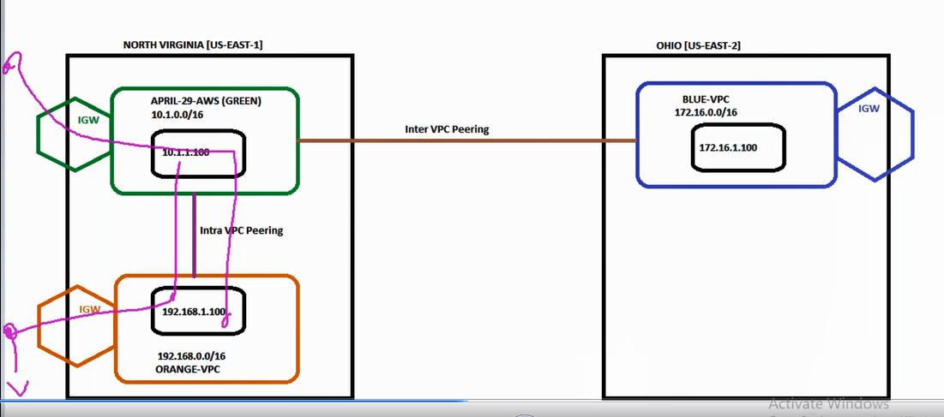

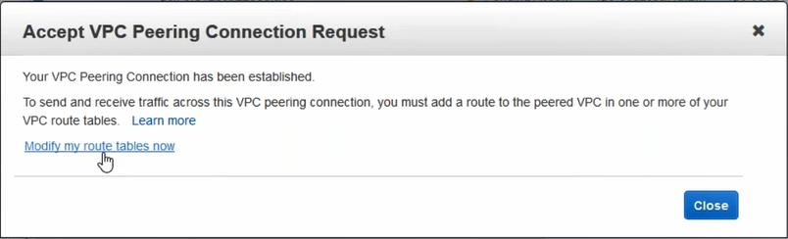

Note :: From OH(172.10.1.202)—MUM(192.168.46.250) there’ll be no peering so it’ll not ping each other.

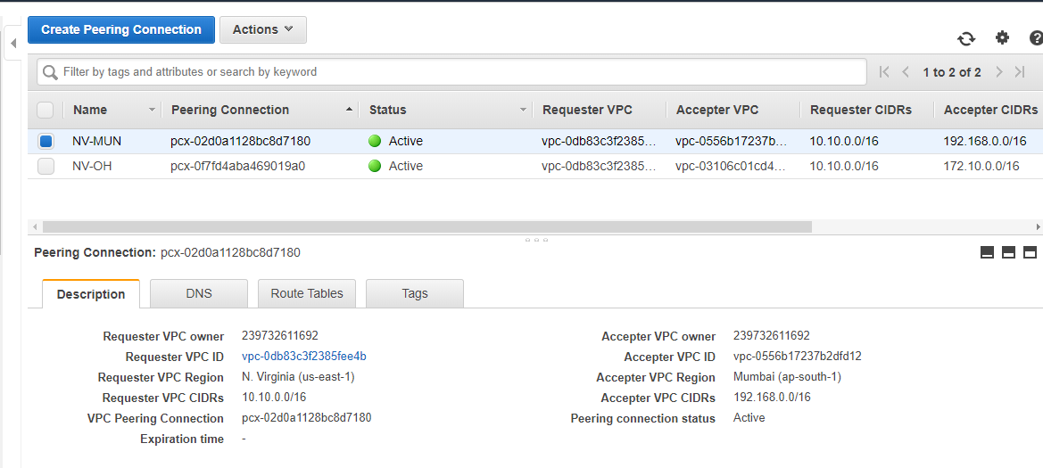

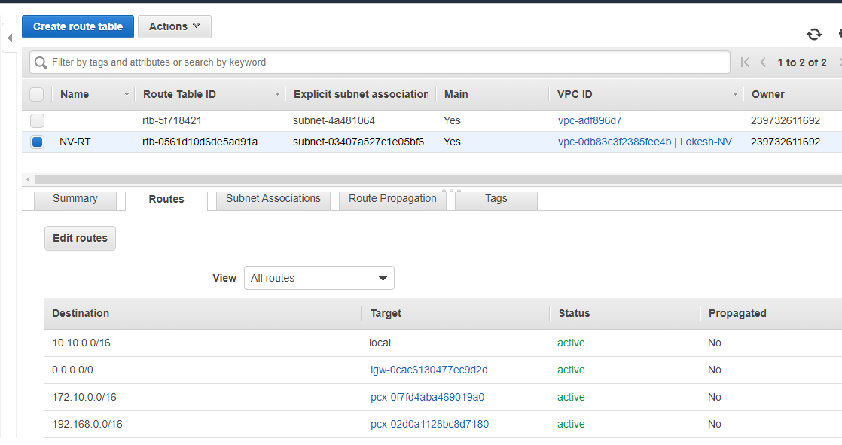

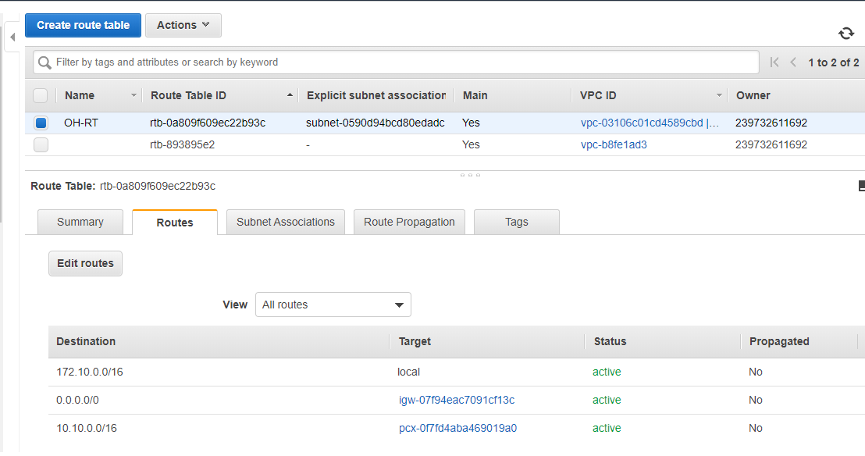

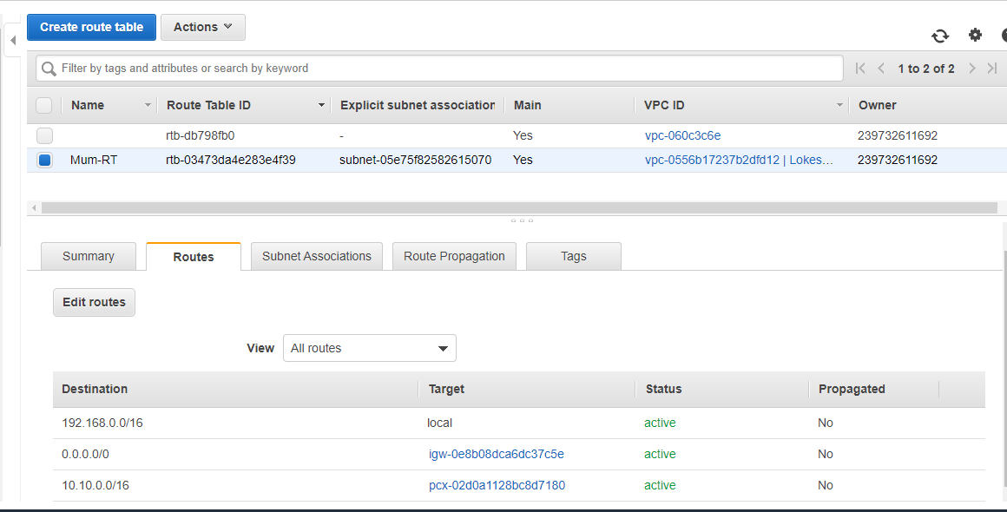

**Note** :: VPC peering is non transitive(instance in Orange VPC cannot communicate to instance In Blue VPC through Green VPC,,,,,need to make that happen by creating peering b/w orange to Blue VPC ,as shown below)

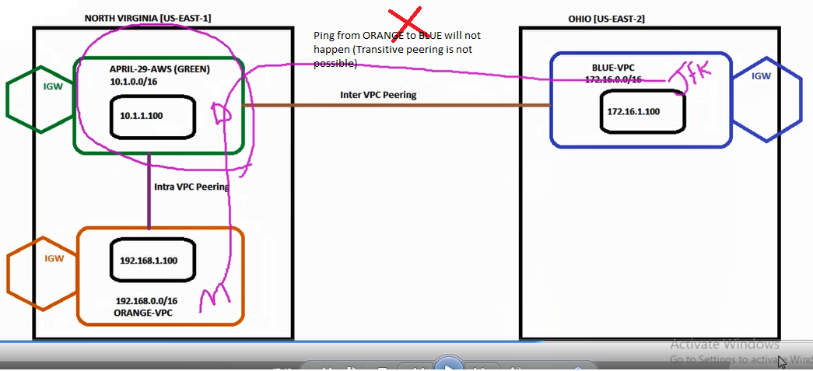

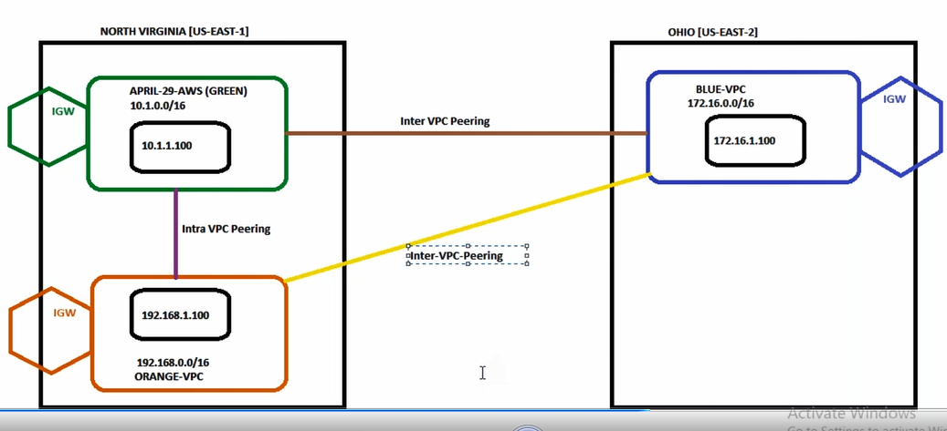

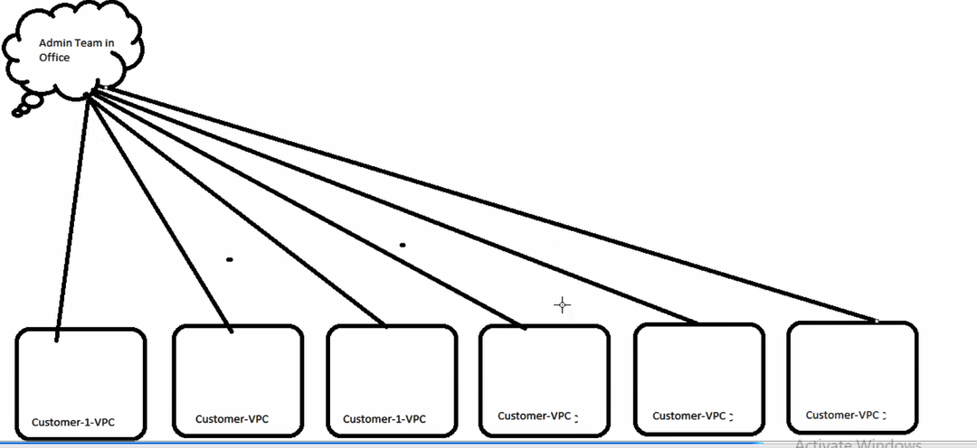

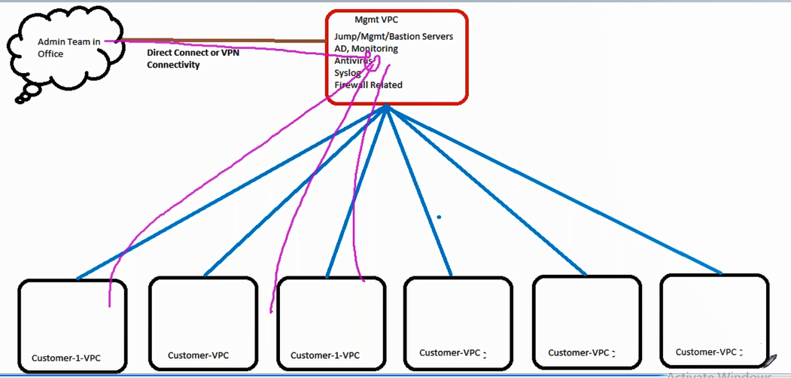

**What is Blackhole error in Peering ?**

While deleting VPC peering connection if we’re not selecting the delete route table entry option ,what will happen is the perring connection will be deleted but the route table entries will remain ,so it results in blackhole error**(entry will bw there but backend connection will not be present so it results in blackhole error)**

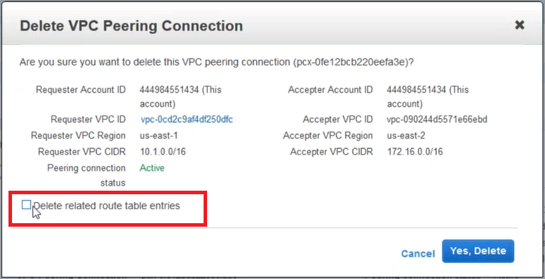

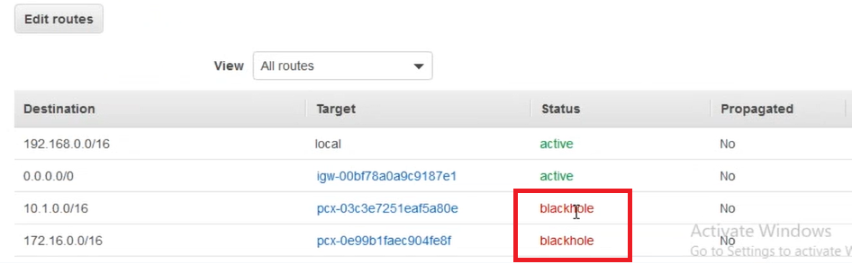

**Transit Gateway :: (Intra)**

One of the concern with VPC perring is if we’ve N no of VPC’s and when we want to do perring b/w them we need to make n+2 route entries,so transit gateway alleviate this issue within the region(Intra)

It also overcomes the problem of transitive perring

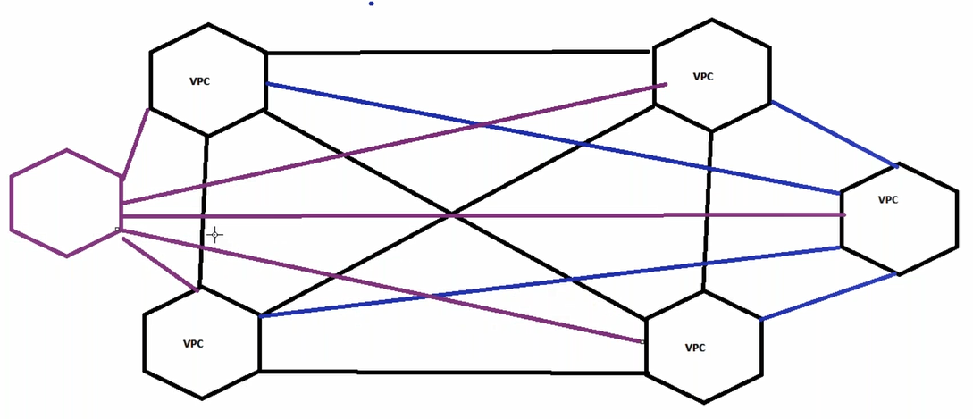

A transit gateway is a network transit hub that you can use to interconnect your virtual private clouds (VPC) and on-premises networks(VPC’s and VPN) within same or diff accounts)

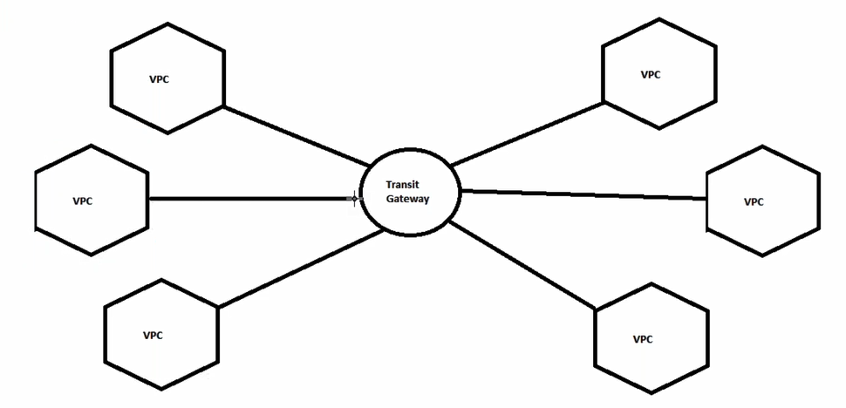

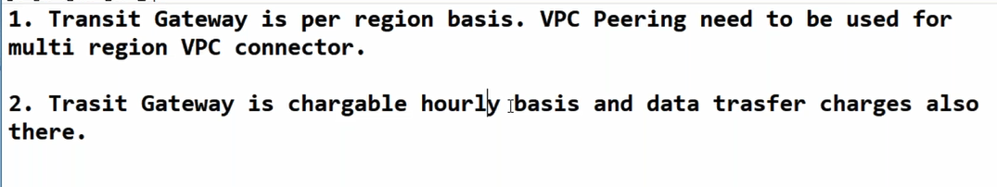

**1.Performance will be better in Transit gateway**

**Note::** Security groups are VPC dependent(U can’t use same security group for all the VPC)

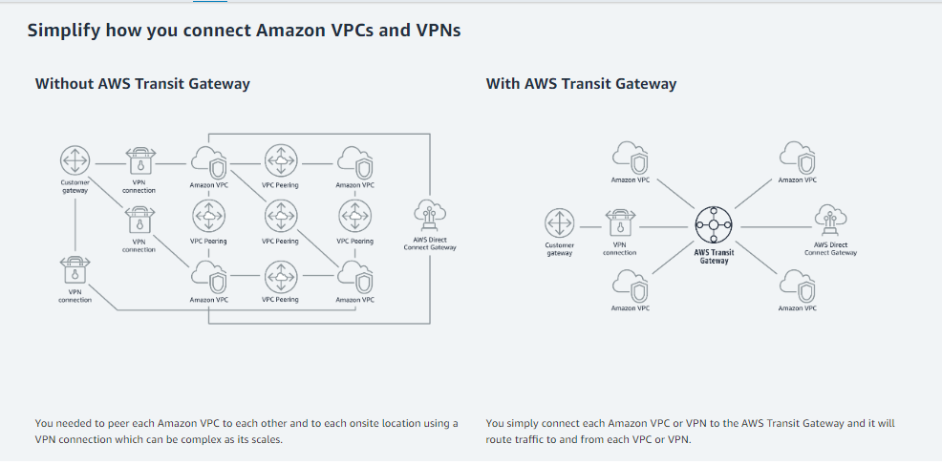

**VPC service limits**

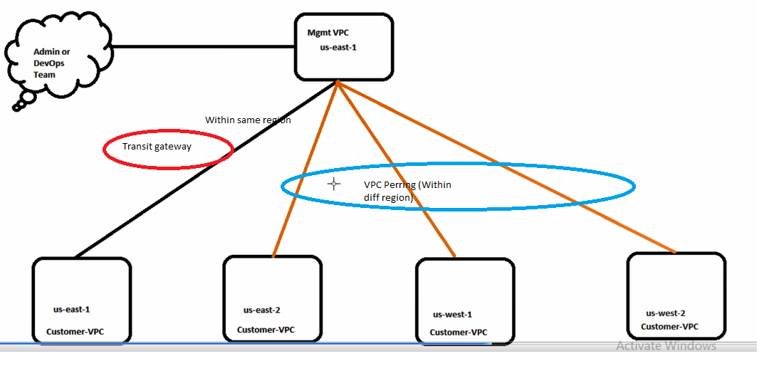

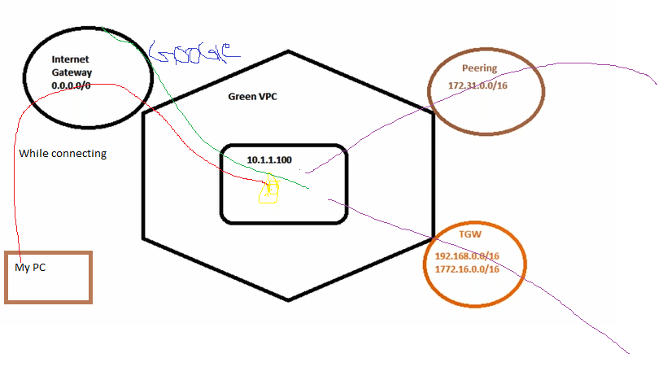

**How to use transit gateway b/w VPC and VPN?**

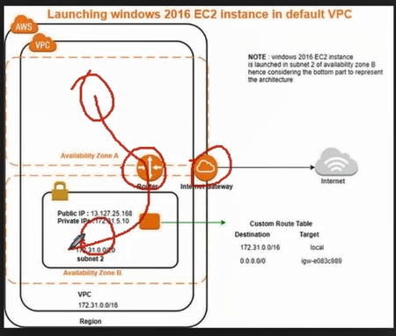

**How to create:**

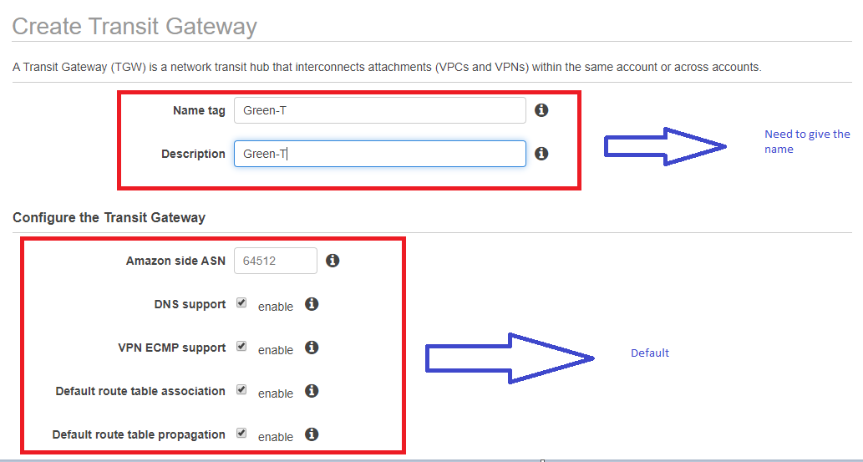

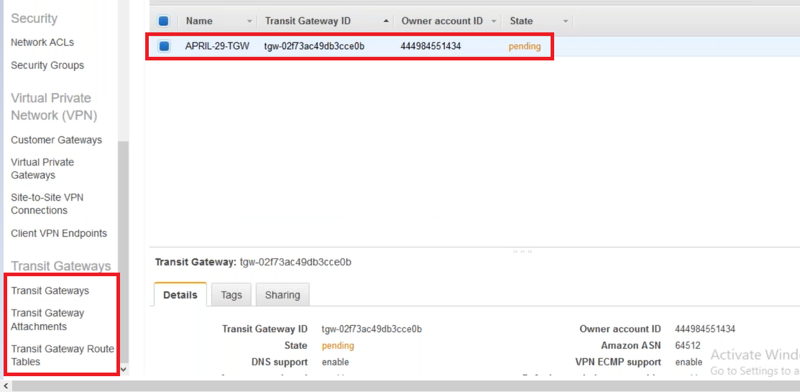

**Attachment:**

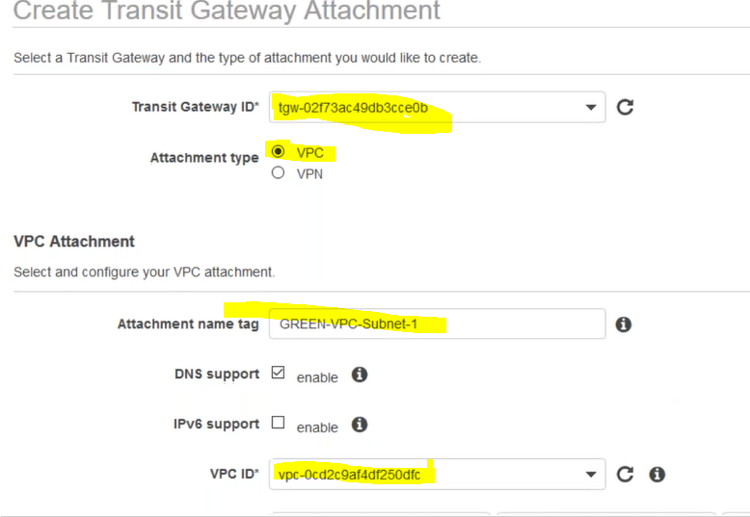

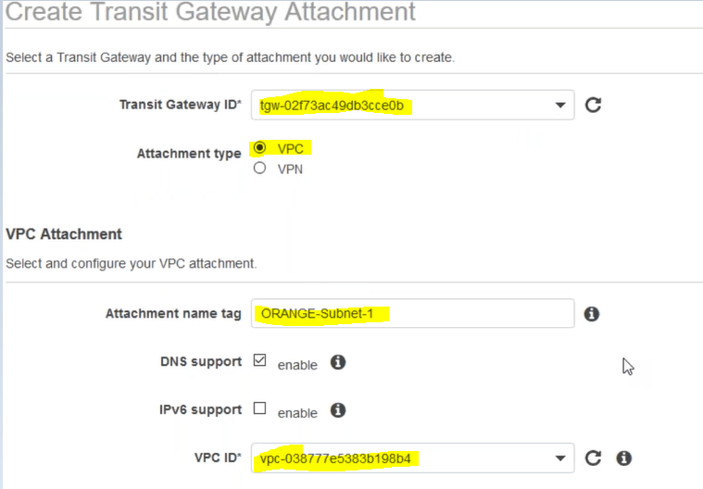

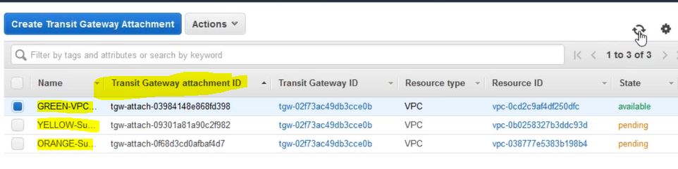

**Egress only internet Gateway:** It is for IPV6

*IPv6 is of 128bit

*There is no concept of private IP,,only public IP’s ,so no inbound only outbound.

**DHCP option set::** We can change the DNS name

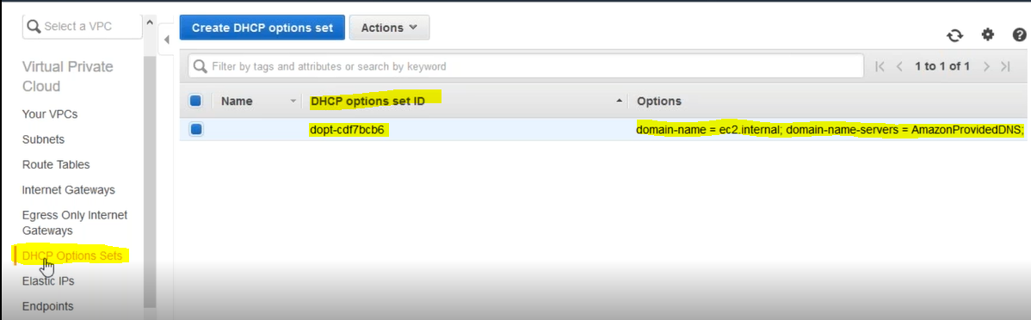

**VPC Endpoints ::**

A VPC endpoint enables you to privately connect your VPC to supported AWS services .

VPCendpoint services powered by PrivateLink without requiring an internet gateway, NAT device, VPN connection, or AWS Direct Connect connection. Instances in your VPC do not require public IP addresses to communicate with resources in the service. Traffic between your VPC and the other service does not leave the Amazon network.

Endpoints are virtual devices. They are horizontally scaled, redundant, and highly available VPC

components that allow communication between instances in your VPC and services without imposing

availability risks or bandwidth constraints on your network traffic.

**Which are all the services does VPC endpoint support?**

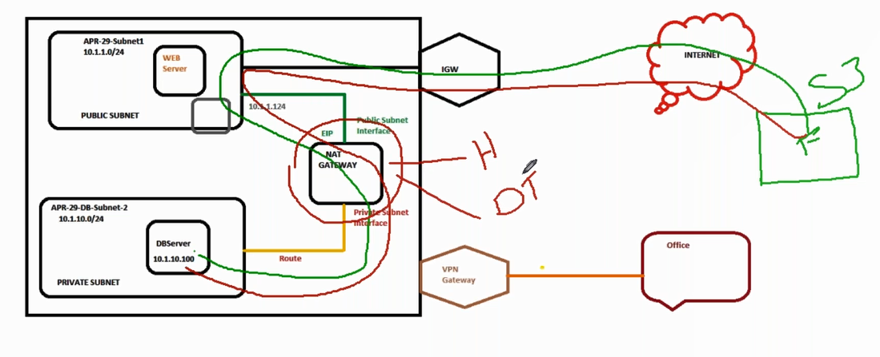

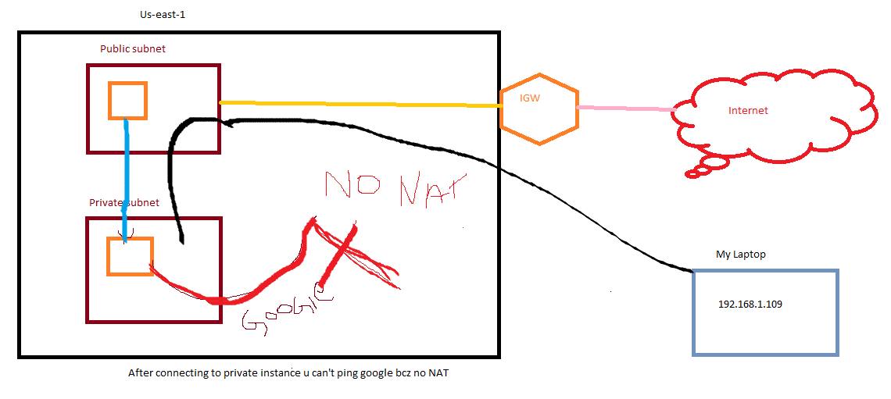

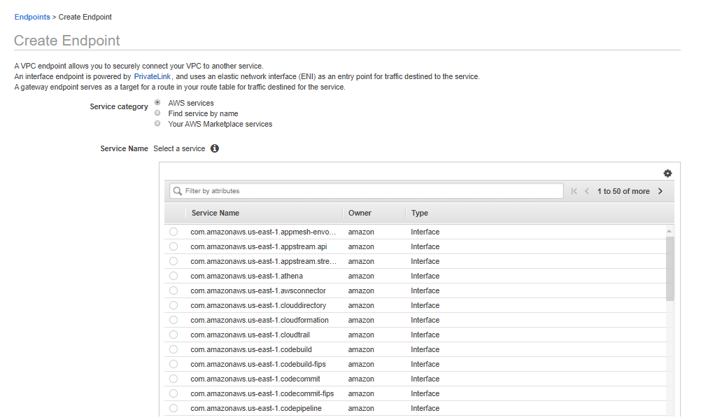

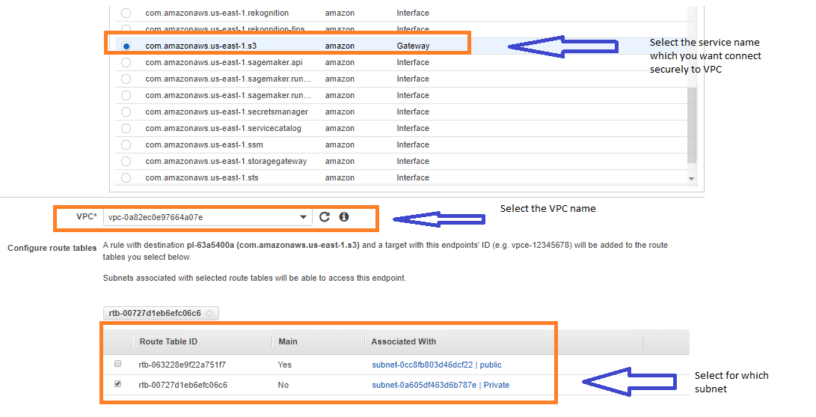

We can create our own policy related to access

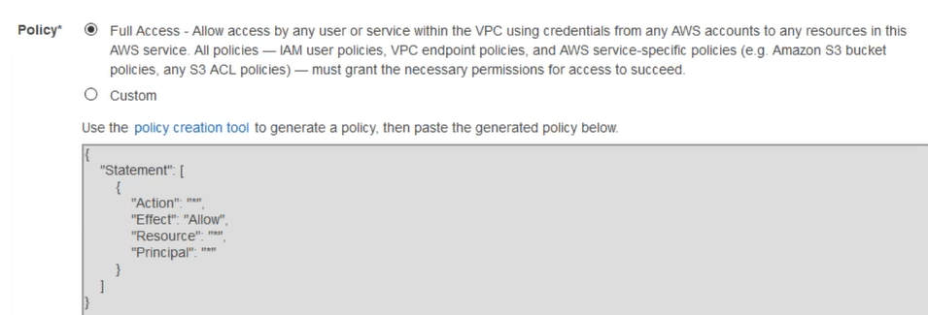

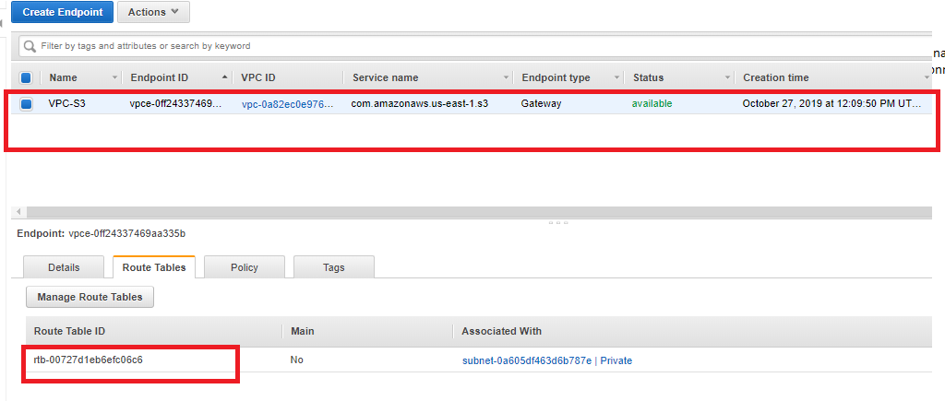

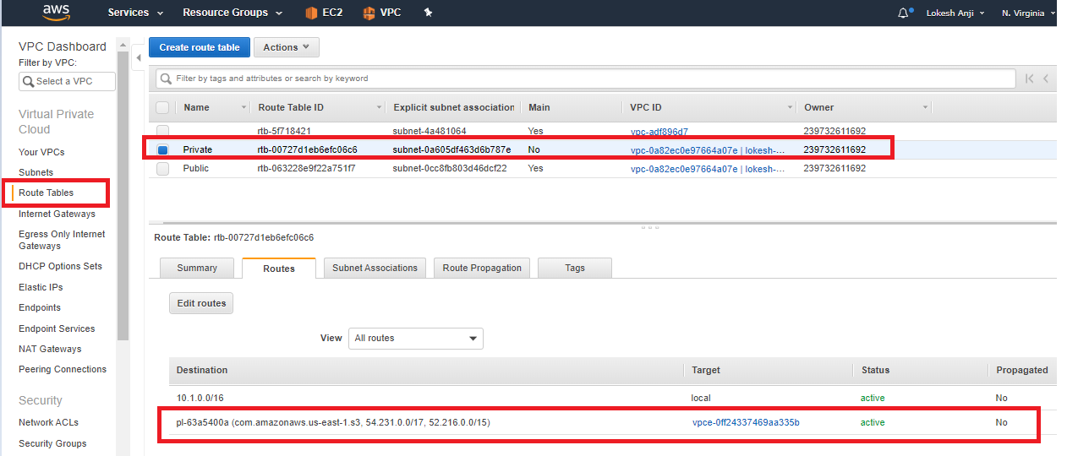

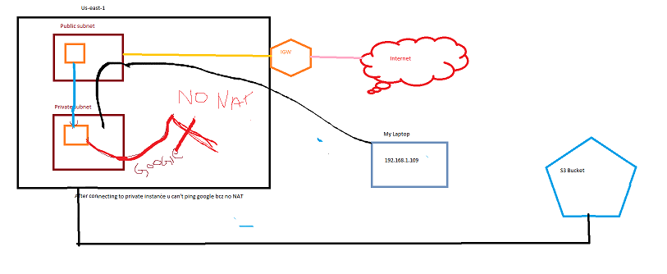

**What is an endpoint service?**

**Security groups: (Resources) Stateful**

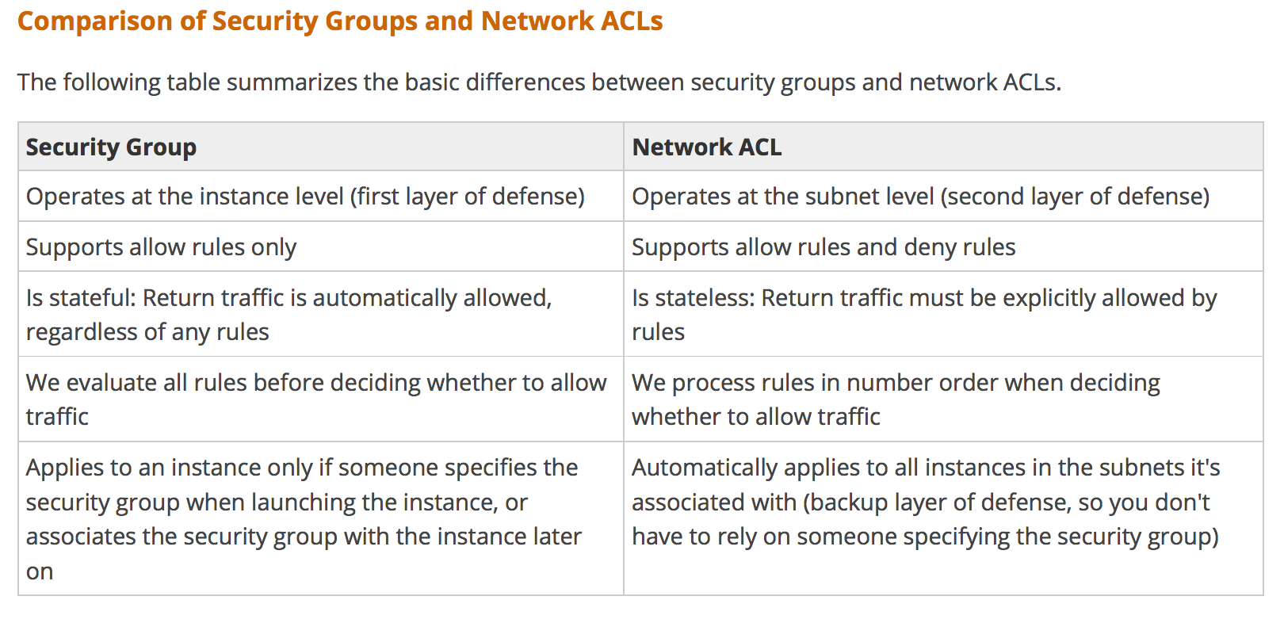

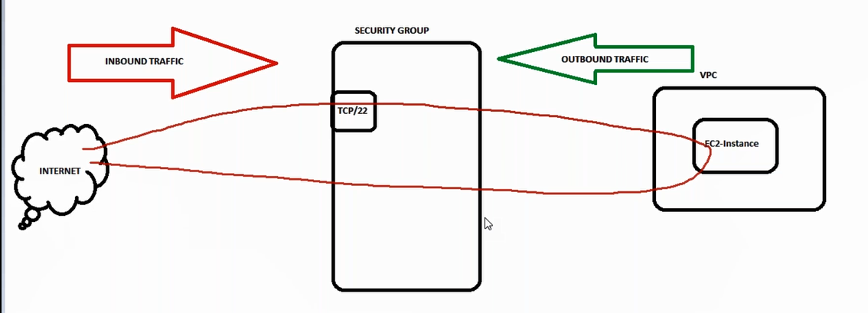

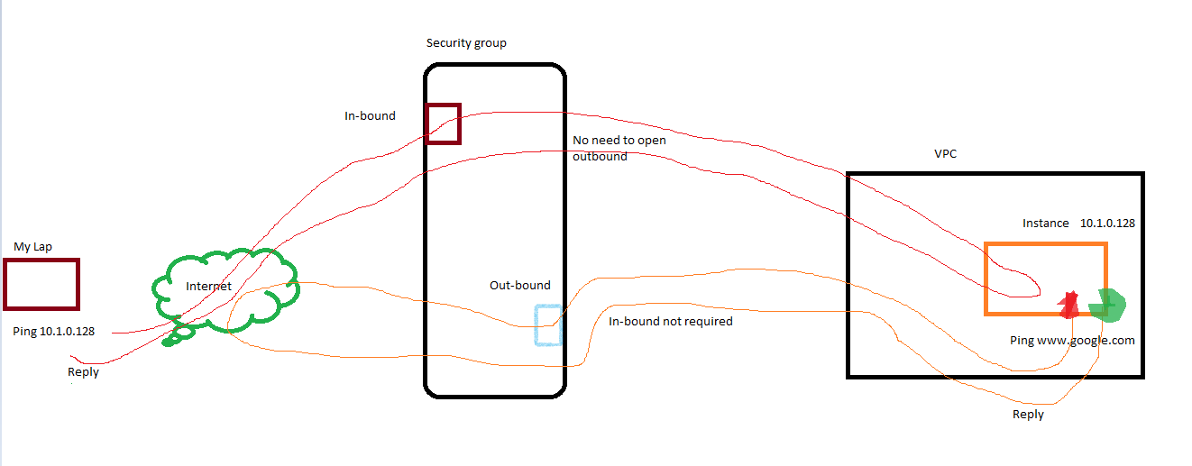

**NACL :: (Higher)**

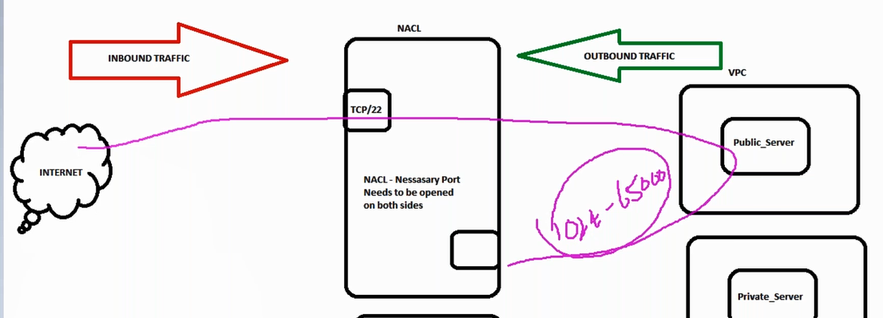

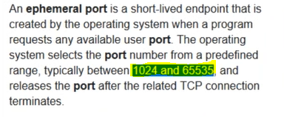

**Default:**

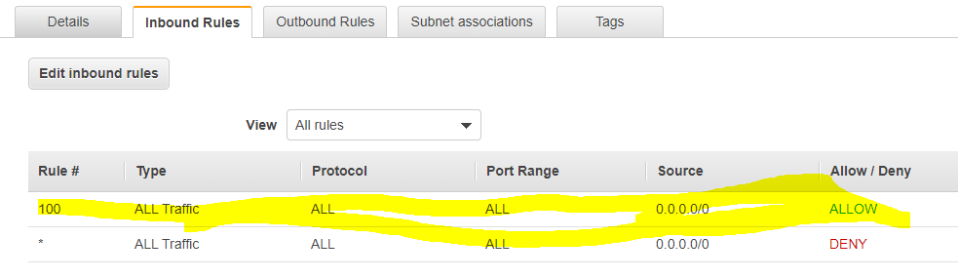

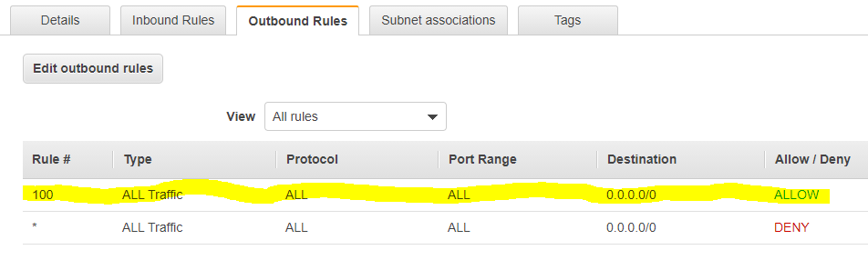

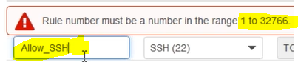

**Customized :**

